**Environmental Care Character Education Based On Local Wisdom For Marine Resource Management**

Marlina1, Ramadhani Lausi Mkumbachi2 ,Azmin Mane3, Laode Rahman Daud4

*1Geography Education, Universitas Negeri Makassar, Jl. Malengkeri, Makassar, Indonesia*

*2Department of Geography, Delhi School of Economics University of Delhi. Delhi India*

*3Geography Education, Muslim Buton, Jl. Betoambari, Baubau, Indonesia*

*4Geography Education, Muslim Buton, Jl. Betoambari, Baubau, Indonesia*

|  |  |  |
| --- | --- | --- |
| **ARTICLE INFO** |  | **ABSTRACT** |
| **Article Hstory:**  Received: ……  Accepted: ..…  Published: .……  **Keywords:**  Geography; Learining; Education; Human; Social  **Corresponding author:**  Copyright © 2022 The Authors |  | The character of caring for the environment through local culture is increasingly being encouraged. However, the concept of integrating local culture in forming an environmentally caring character in managing marine resources has not been implemented. Meanwhile, environmental awareness is important to realize good environmental quality. The community must have the character of caring for the environment as a conservation effort, including the concern of the Bajo community in managing the Wakatobi National Park area. The aim of this research is to examine the local wisdom values of the Bajo Mola community in Wakatobi National Park, including the local wisdom of Duata Sangal, Parika and Pamali contained in environmentally caring character education which is integrated through high school geography learning. The research method uses descriptive qualitative with data collection through interviews, observations and literature reviews which are analyzed using model triangulation. The results of the research are that character education that cares about the environment can be developed through the use of marine resources through the local wisdom of the Bajo Mola community. Bajo Mola local wisdom values in class XI Geography learning. Educators can apply it by integrating it into learning material, so that they can form environmentally. Caring characters in students. As a community with a maritime culture, local wisdom values contain indicators of environmentally caring character that can be integrated into geography learning. Management of marine resources in Wakatoi National Park is carried out by involving the entire community through local wisdom and is considered capable of protecting the National Park which directly and indirectly provides benefits to the community and the environment. Therefore, local wisdom needs to be maintained in creating a generation that cares about the environment. |
| C:\Users\user01\AppData\Local\Microsoft\Windows\INetCache\Content.MSO\E970812.tmp  This open access article is distributed under a  Creative Commons Attribution-NonCommercial  (CC-BY-NC) 4.0 International License |
| **How to cite:** | | |

1. **Introduction**

Human life is always influenced by the environment. Environmental sustainability is also greatly influenced by humans. Human behavior in utilizing nature determines environmental conditions. If the environment is not maintained, its sustainability can have a negative impact on humans, whereas if it is maintained it can provide welfare for humans. However, currently the problem of human relations with the environment has become a global issue. Natural factors such as natural disasters and low human awareness of preserving sustainability are factors that cause environmental damage. There have been several cases of environmental damage on land and at sea due to unwise human activities which have had a major impact on conservation efforts. So ongoing efforts are needed to provide education to humans so that they are always aware and care about the environment. Environmental problems are caused by humans' ability to control nature by exploiting it excessively for their own interests without paying attention to the environment. This is an environmental problem of the 21st century which is triggered by the development and application of science and technology that is not wise and does not have an environmental perspective so that it has a negative impact on every aspect of life.

Environmental education can be carried out formally or informally. Increasing education about nature and the environment through coaching and training in formal and non-formal channels as a form of love for nature, the environment and each other (Hadi & Anazifa, 2016). Therefore, formal and non-formal education is very necessary to change people's attitudes. All levels of society have the right to receive environmental education, so that awareness of environmental conservation can grow within them. It is important to form an environmentally caring character based on Indonesian culture. Placing a cultural paradigm in environmental education can be used as an effort to instill environmentally caring character education based on local wisdom. This is in accordance with one of the main designs for building national character in 2010-2025, namely building national character is a must for a multicultural nation (Yunus, 2013). Building character requires the involvement of several parties such as family, government, formal and non-formal institutions and the wider community in accordance with their respective local wisdom.

The study of environmental care character education is a change in human attitudes towards the environment in the form of actions in daily life which are an effort to prevent damage to the surrounding natural environment, as well as trying to repair all natural damage that has occurred (Purwanti, 2017). The formation of an environmentally caring character can start from the school environment by maintaining school cleanliness (Ismail, 2021). Instilling an environmentally caring character is one effort to make people care about the environment. This effort is in order to preserve nature and the environment so that damage does not occur, namely by protecting the environment. Humans are expected to care about the environment, but in reality there are still many people who do not care about the environment, especially the younger generation as agents of change. Character education in schools is an academically conducive environment, both physically or non-physical. The importance of promoting environmentally caring character education to instill an attitude of caring for the environment in the community, this is closely related to the region. Apart from that, environmental education is the key to preparing people to have an environmentally caring attitude that is able to solve environmental problems (Muslicha, 2015).

Considering the importance of efforts to manage Wakatobi National Park as a marine conservation area, environmental care movements must grow together in people's lives. Management must be carried out as a form of human responsibility towards nature. Marine resource conservation can be integrated by involving local communities (Sumarmi et al, 2020; Marlina et al, 2021). Exploring traditional knowledge or local wisdom in management plays an important role in maintaining sustainability while still considering the welfare of coastal and marine communities. The Bajo people have a unique maritime cultural system, which if explored, studied and developed can be adapted for managing coastal and marine resources (Wani & Ariana, 2018; Bennett, 2019). explained that limited teaching materials have the potential to cause discrepancies and conflicts among students. Meanwhile, ideal geography teaching materials come from the environment around students. So that the knowledge gained is meaningful and useful.

The novelty of this research is that there is no research that links local Bajo wisdom and marine management in building environmentally caring character in students at school through learning geography. While Wakatobi Regency's position is that it is a marine protected area, it must incorporate the local wisdom of the local community in managing the area. Apart from that, character education is expected to be able to build environmental awareness to preserve the resources of Wakatobi Regency. The character of caring for the environment must grow in every student. Implemented in schools at every level of education. Environmentally caring character education can help educators instill environmentally caring character in students which will underlie their behavior in everyday life. The aim of environmental care character education is to encourage habits of managing the environment well to prevent environmental damage. Instilling the character of caring for the environment is one effort to make people care about the environment. Humans are expected to care about the environment, but in reality there are still many people who do not care about the environment, especially the younger generation. The younger generation as agents of change.

1. **Methods**

This research uses a qualitative descriptive method with data collection techniques through in-depth interviews, observation and literature review. Data collection was carried out in May-August 2022. The informants in this research were the local government, Bajo community leaders, cultural figures and geography teachers at 3 high schools. To obtain data regarding the local wisdom of the community, it was obtained through in-depth interviews with the government, cultural and community figures. This is intended to obtain in-depth information about the existence of local community wisdom in managing marine resources. Meanwhile, the geography teachers we interviewed aimed to obtain information on how the integration of local wisdom in learning is included in the context of implementing environmentally caring characters in students.

Data was obtained from key informants, namely traditional leaders and supporting informants consisting of the Bajo Mola community and the Bajo Mola village head. Data analysis uses a triangulation model to examine the values of Bajo Mola local wisdom contained in environmental care character education, then integrated into class XI high school geography learning material 1) Flora and Fauna in Indonesia and the World, 2) Natural Resource Management in Indonesia in geography learning at school. The location of this research is in the Wakatobi National Park area, especially in the Bajo Mola community settlement which is administratively divided into five villages, namely Mola Nelayan Bakti Village, South Mola Village, Mola Samaturu Village, North Mola Village, and Mola Bahari Village. , South Wangi-Wangi District, Wakatobi Regency. The research location can be seen in Figure 1.

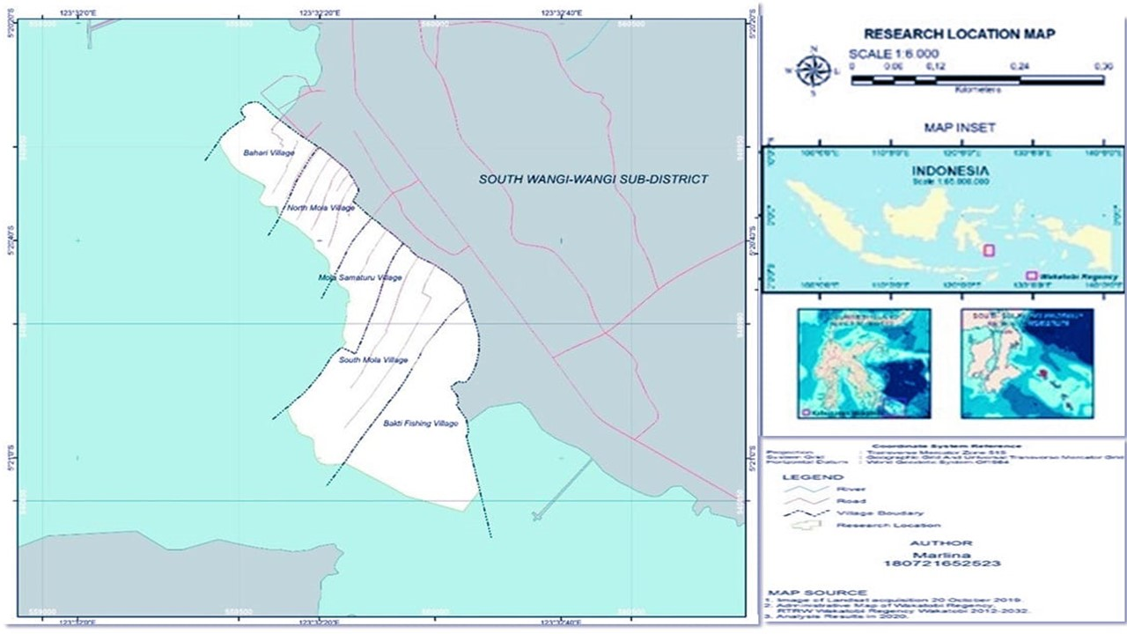

**Figure 1.** Research Location (Bajo Mola Residential Area)

1. **Results and Discussion**

Bajo Mola Village is the name for 5 villages in Bajo. To get to Bajo Mola Village there is 1 main gate, Bajo Mola Village first only consisted of two (2) villages but then became five (5) villages, namely Bakti fishermen village, south side, south Mola village, Mola samaturu village, north Mola village and Mola Bahari Village, basically the five Mola Villages have the same physical and social conditions, but based on administrative considerations they have become five Villages. The Bajo Mola community settlements in Wakatobi Regency are administratively divided into 5 villages, namely Mola Nelayan Bakti Village, South Mola Village, Mola Samaturu Village, North Mola Village and Mola Bahari Village. These five villages, better known as Mola Village or Bajo Village, are 5 villages in the South Wangi-Wangi District area.

The geographical conditions of the Bajo residential area are greatly influenced by the Flores sea and the Banda sea. During the west season in the Bajo Mola area there are big waves, while in the east season the sea currents are relatively calm. In the Mola area there are several important ecosystems, namely seagrass and coral reef ecosystems, in which various types of marine biota live, such as rabbitfish, crabs, sea cucumbers, shellfish and other small fish. The area of the Bajo Mola settlement is ± 8.3 km² and is divided into 5 villages with the majority of the population making a living as fishermen. The total population distribution is:

**Table 1** Number of residents in each village in the Bajo residential area 2021

|  |  |  |  |  |  |
| --- | --- | --- | --- | --- | --- |
| No | Village | Number of Family | The Total Population | | The Total Population |
| Laki-laki | Perempuan |
| 1 | Mola Selatan | 626 | 1041 | 1.052 | 2.098 |
| 2 | Mola Utara | 313 | 532 | 520 | 1.052 |
| 3 | Mola Samaturu | 2679 | 521 | 511 | 1.040 |
| 4 | Mola Bahari | 354 | 663 | 645 | 1.308 |
| 5 | Mola Nelayan Bakti | 644 | 1164 | 1.394 | 2.558 |
|  | Total | 2.210 | 3.931 | 4.126 | 8.057 |

**Source:** Profile of 5 Villages of the Bajo Mola Community, 2021

Education is an important factor in developing the knowledge of the Bajo Mola community. Educational facilities such as schools, including Kindergartens (TK), Elementary Schools (SD), Middle Schools (SMP) and High Schools (SMA), should be given attention so that they can facilitate the community to pursue education in the hope that the next generation will be able to follow suit. the current development of the times without losing knowledge of local cultural wisdom. The progress of a society can be measured by the level of education of citizens and is a driving factor for the development of new ideas that are able to stimulate change in various areas of life. The level of education of the people of Bajo Mola is relatively low, several factors that influence this are the very lack of community motivation, where life at sea has an impact on the public's perception that education is not an important thing. According to them, going to high school is useless if you end up working as a fisherman.

**Table 2.** Condition of education level of the Bajo Mola community

|  |  |  |  |  |  |  |
| --- | --- | --- | --- | --- | --- | --- |
| No | Education level | Village | | | | |
| Mola Selatan | Mola Utara | Mola Samaturu | Mola Bahari | Mola Nelayan Bakti |
| 1 | No school | 1.571 | 193 | 171 | 677 | - |
| 2 | Not yet at school | 162 | 92 | 87 | - | - |
| 3 | Graduated from elementary school | 34 | 200 | 230 | 483 | 397 |
| 4 | Finished junior high school | 48 | 145 | 133 | 83 | 209 |
| 5 | Graduated from high school | 27 | 140 | 116 | 50 | 178 |
| 6 | D3 | - | - | - | 1 | 2 |
| 7 | Bachelor | 9 | 31 | 27 | 14 | 69 |
| 7 | Kindergarten student | - | 23 | 39 | - | - |
| 8 | Elementary student | 158 | 102 | 123 | - | - |
| 9 | Middle school students | 52 | 66 | 96 | - | - |
| 10 | Senior High School student | 34 | 52 | 26 | - | - |
|  | Total Population | 2.095 | 1.052 | 1.038 | 1.308 | 2.554 |

**Source:** Profile of 5 Villages of the Bajo Mola Community, 2021

The economic condition of the community and the perception of the Bajo Mola community is one of the factors causing the low level of education of the Bajo Mola community, not because of the lack of income as fishermen but because of poor family financial management, this is caused by the large amount of household expenditure compared to the amount of income. , as well as the high consumptive nature of society. The Bajo Mola community as a whole is Muslim. In social life apart from Islamic religious law, belief in their ancestors is still quite strong. Bajo people consider that their ancestors at sea will be able to protect them. This is demonstrated by the existence of traditional ceremonies or special rituals at sea known as the Duata ritual.

* 1. **Utilization of marine resources based on local wisdom of the Bajo Mola community**

The closeness between the people of Bajo Mola and the Wakatobi sea has been alive and well for a long time, they even call themselves sea people. The life and livelihood of the Bajo people is spent at sea. They eat and live in the sea. Having a culture that is very much connected to the sea since being born by being immersed in the sea is a form of how the Bajo people perceive the sea as life. There is a close relationship between society and the sea. For the Bajo people, marine life gives special meaning to their lives, the sea provides food and the sea provides protection. The meaning of the sea for the Bajo tribe has directly formed a unique culture so that even though the transformation of society towards modernization is very rapid, this does not mean that ancestral culture has been abandoned.

In their daily lives, the Bajo people spend more time gathering in front of the house and this is a symbol of togetherness and strong family ties. If there are neighbors (fishermen) who get excess sea products, usually the results are distributed to neighbors around their house. This has become a habit that continues to this day, and for the Bajo people, they never feel short of food supplies. Because according to the Bajo Mola people, the sea is their source of life and they never lack it.

The Bajo people think that whatever is in the sea is food that is available to them, in fact the Bajo people prefer seafood to be eaten 'raw' without being cooked or grilled. This is passed on to their children, as the successors of the Bajo lineage, they are taught to live according to their identity as sea people, so from childhood children are taught to live in the sea and not be afraid of sea water. Many Bajo children Mola who enjoys life in the sea. Moreover, since childhood they have been accustomed to enjoying seafood without cooking or grilling, and interestingly all of this is enjoyed by the children of Bajo Mola Wakatobi.

.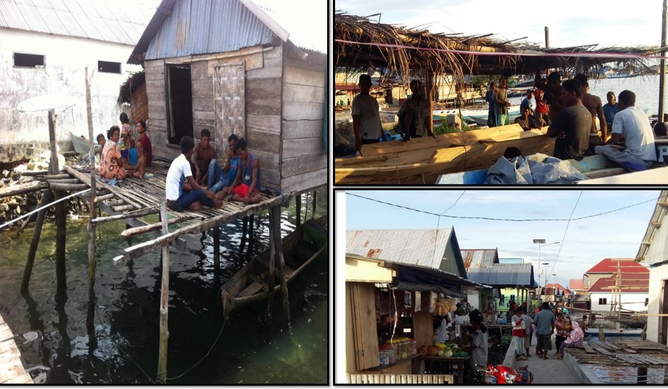

**Figure 2.** Portrait of people's daily lives in the afternoon (Source: of research, 2022)

The Bajo Mola community still respects and upholds the culture and customs of their ancestors, this is proven. the cultural order and local wisdom still apply in every wedding procession and going out to sea. The forms of conservative tradition that still survive and apply in Bajo society are as follows:

3.1.1 Duata Sangal

Duata sangal is a duata sangal procession that is simpler than the duata ritual for treatment. The duata sangal procession is carried out at sea by folding betel leaves (luppiseba) in which other ingredients such as areca nut, lime, gambier and tobacco are filled with 4 (four) betel leaves with the ends of the betel leaf line. must be in the top position. Four folds of areca nut slices inside a betel leaf (sangal) are then lowered into the sea with a prayer that has been recited previously. slowly coming back together.

The Bajo people believe that the movement of the sangal is not solely due to sea currents, the sangal is a guide for the ancestors of the Bajo people when going to sea. The sangal movement can provide an indication of the amount of good fortune that can be obtained that day. The results of the interview show that if the sangal are far away from each other (separate) and then gather again, it means that the fortunes of the Bajo fishermen will be very large, the catch will be abundant, whereas if the sangal continue to gather secretly and their movement is a little slow, this shows that the fate of the Bajo fishermen is somewhat reduced. In fact, there is none at all, apart from that, the Sangal procession of the Bajo people when they encounter obstacles and obstructions at sea, the sangal which is lowered has the meaning as a form of greeting for fishing activities, another meaning is as a form of request by the Bajo people to the Creator for all the abundance of marine products that they have received. given to humanity.

The existence of local tribal wisdom has become a record of how Indonesia is very rich in customs and traditions, including rituals related to environmental management. Not only the Baji people, for example: Water resources in Kuta Village are used for two functions, namely to meet daily needs and to nyipuh traditional ritual in the Sacred Forest (Hilman & Hendriawan, 2018). Another example is the Blumbang Surgery at the foot of Mount Unggaran, Semarang Regency, which now functions to protect water resources (Wiyatasari & A Lathifah, 2019; Marlina et al. 2022), for example in protecting forests with the traditions of the Bulukumba indigenous community's pairsriakajang (Syarif et al, 2023). It cannot be denied that many traditions are born with a religious character. Phenomena that exist in people's culture are basically a stimulus to enrich scientific knowledge.

3.1.2 Parika

The emergence of a knowledge system is the result of a process of adaptation to nature and is a form of local wisdom. Local wisdom is intelligence/knowledge or way of life in the form of local community activities (customs, religion, science, economics, communication, and art) in responding to various problems to maintain, improve, develop elements of their needs by paying attention to ecosystems and natural resources. Humans. In the Bajo Mola Wakatobi community, the system of knowledge of the sea is a gift from the creator and has been owned by the Bajo people since their ancestors.

The intelligence and knowledge of the Bajo people in utilizing marine resources is reflected in the intelligence of the parika (a fisherman leader). Parika, with his knowledge, is trusted by Bajo fishermen to be able to organize and direct fishing activities, of course with abundant catches. Parika has a big task so to become a parika you have to fulfill certain requirements. The requirements to become a parika are (1) knowledgeable and experienced enough to lead fishing activities, (2) leadership spirit, (3) responsible and (4) trustworthy.

3.1.3. Pamali

Pamali is a sentence that is often interpreted as a prohibition or silent abstinence. Not only in social life, the term pamali is widely used to conserve resources as an unwritten rule passed down from generation to generation by the community. For example, the existence of Pamali culture in the management of the Reban Bela Traditional Forest has been proven to preserve the ecosystem within it, so that the water resources within it are also well maintained, local wisdom in the form of Pamali culture has succeeded in preserving it. forest and water resources in Lenek Daya Village. This local wisdom is a form of implementing forest and water conservation (Reza, M. & Hidayati, 2017), including in Wakatobi the term Pamali is also used for cave water conservation in community life. Bajo Pamali tribal community for marine sustainability (Marlina et al 2020).

Pamali means taboo, namely a prohibited area designated by traditional leaders for fishing, and sanctions are set for those who violate it. A person who carries out fishing activities in this zone is an offense and can be given sanctions in accordance with applicable regulations. Pamali Bajo is a form of rule that must be obeyed by all Bajo people, especially fishermen who carry out fishing activities.

In the Bajo Mola community, the known location of Pamali is around the Kapota reef. There are 3 Pamali locations, namely maduangalo (yard or front of the house), mabulisapa (back of the house) and torosapa (a rock marked by a large coral in the shape of a fisherman on a boat). The location of Madungalo is the Pamali area around the tip of the Kapota and Mabulisapa reefs to the Kaledupa reef. Activities that are prohibited from being carried out at the Pamali location include swearing, shouting, engaging in immoral relations and throwing rubbish carelessly. Even though the Bajo people know that the Pamali area is a zone with lots of fish, the Bajo people do not dare to carry out activities in this zone. According to them, even screaming is prohibited, let alone carrying out bombs, using potassium or anesthesia

**3.2 Values in the utilization of marine resources Based on local wisdom Bajo Mola To Grow Environmental Care Character Education**

The policy regarding character education is contained in Law Number 20 of 2003 concerning the National Education System Article 3 which states that "national education functions to develop abilities and form dignified character and national civilization in order to make the life of the nation intelligent, aiming to develop good character. dignity and civilization of the nation in order to educate the life of the nation, which aims to develop the character and civilization of the nation. the potential of students to become human beings who believe and are devoted to God Almighty, have noble character, are healthy, knowledgeable, capable, creative, independent and become democratic and responsible citizens." related to character.

Based on these regulations, the obligation to instill the character of caring for the environment is important in learning at school, especially in geography learning at high schools in Wakatobi Regency. Environmentally caring character education is one of the eighteen characters established by the Curriculum Center of the Ministry of National Education The aim is for the environmentally caring character to form an attitude and action to prevent damage to marine management in Wakatobi. so it must be implemented in schools at every level of education. Through the results of interviews with geography teachers at high schools in Wakatobi Regency, they said that character education that cares about the environment can help students become aware of the environment which can underlie their behavior in everyday life. For example, raising awareness by not throwing rubbish into the sea has created an issue about cases of destruction of the marine environment that will be detrimental in the future. In the end, character education that is always sought to be instilled in students' minds is to care about their environment. Formulating the goals of character education, namely creating a conducive school environment, forming emotional and spiritual intelligence, strengthening positive behavior, correcting various negative behaviors, motivating and familiarizing students with realizing various knowledge about goodness (Najib, 2016). The values contained in the wisdom of the Bajo Mola people contained in the character of caring for the environment can be seen in more detail in table 3. **Table 3** The value of the local craftsmanship of the Bajo Mola community as contained in the Character of Caring for the Environment

**Table 3** The value of the local craftsmanship of the Bajo Mola community

|  |  |  |  |
| --- | --- | --- | --- |
| Bajo Mola local wisdom (Duata Sangal, Parika, and Pamali) | Value and Meaning | Environmental Care Character Indicator | |
| Damage Efforts to Repair Damage | Damage Efforts to Repair Damage |
| Prohibited activities: | The ecological value that this prohibition implies is to protect forests from damage | √ | √ |
| It is prohibited to carry out non-environmentally friendly fishing activities such as booming, trawling and fishing. |  | √ | √ |
| Allowed activities: | -. The value of balance which contains the meaning of living in harmony with nature can be seen from the rules for using the sea | √ | √ |
| Activities that are allowed are: catching fish at a certain time to get more fish by using environmentally friendly fishing | - Sustainability value | √ | √ |

(Source: of research, 2022)

Developing character in students through the values contained in local wisdom (Permatasari & Hakam, 2018). For example, the wisdom of the Bajo Mola people in the use of the sea (customary rules/law) regulates the behavior of indigenous peoples in the use of sea resources by containing several prohibitions aimed at preserving them. One of the prohibitions is that you are not allowed to fish in the Pamali area in accordance with customary law. This rule contains indicators of environmental care character. Indicators of environmentally caring character are attitudes and developing efforts to repair natural damage.

Based on table 1, it provides an explanation of the value of the local wisdom of the Bajo Mola people in marine use, containing indicators of environmentally caring character. Therefore, character education that cares about the environment can be developed through the use of marine resources based on local wisdom which contains the values of ecology, balance, mutual cooperation and sustainability. This research analyzes the use of knowledge and conducts community-based participatory communication to propose a communication framework for protecting Wakatobi National Park. The value of local wisdom contained in the environmentally caring character indicator can also be integrated into geography learning in high school. Integration of the values and meaning of Bajo Mola wisdom in Class XI High School Geography learning in Table 4.

**Table 4.** Integration of Values and Meanings of Bajo Mola Local Wisdom in Class XI Geography Learning

|  |  |  |  |
| --- | --- | --- | --- |
| Local Wisdom of the Bajo Mola Community | Value and Meaning of Materials | Flora and Fauna in Indonesia and the Material World | Natural Resource Management in Indonesia |
| Duata Sangal Parika, Pamali contains a deep meaning regarding the wise use of marine resources - Ecological and sustainability values contained in the knowledge of the Bajo Mola community in managing, preserving and protecting the sea for the sustainability of its functions. | - Ecological and sustainability values are found in the knowledge of the Bajo Mola people in managing, preserving and protecting the sea for the sustainability of its function.  - The value of balance and mutual cooperation from the obedience of the Bajo Mola community | Basic competencies:  3.2 Analyze the distribution of flora and fauna in Indonesia and the world based on ecosystem characteristics. | Basic competencies:  3.3 Analyze the distribution and management of forestry, mining, marine and tourism resources according to the principles of sustainable development. |

(Source: of research, 2022)

Table 4 explains the integration of Bajo Mola local wisdom values in class XI Geography learning. Educators can apply it by integrating it into learning material, so that they can form environmentally caring characters in students. Learning that involves the environment as a learning resource can shape character and increase students' awareness of the environment (Fua et al. 2018).

1. **Conclusions**

Based on the research results, it can be concluded that environmental care character education can be developed based on the local wisdom of the Bajo Mola Community in managing the marine environment of Wakatobi National Park. The wisdom of the Bajo Mola Community contains indicators of the character of caring for the environment in the aspect of character education. The potential for local wisdom in Duata Sangal Parika, Pamali contains deep meaning regarding the wise use of marine resources. Ecological and sustainability values contained in the knowledge of the Bajo Mola people in managing, conserving and protecting the sea for the sake of its continued function. High school teachers in Wakatobi Regency make local wisdom values a geography learning topic, namely in class XI high school geography learning material about 1) Flora and Fauna in Indonesia and the World, 2) Management of Natural Resources in Indonesia in geography learning at school. The values and meanings contained in the local wisdom of the Bajo Mola Community are integrated into geography learning in high school to continuously educate and develop the character of caring for the environment. Apart from providing input on how local wisdom can be integrated in learning to instill environmentally caring character, this research needs to be carried out further regarding effective learning methods or models to achieve learning objectives with the main aim of instilling attitudes.

**References**

Bennett, N.J. (2019). Marine social science for the peopled seas. *Coastal Management*, 47(2), 244-252. <https://doi.org/10.1080/08920753.2019.1564958>

Fua, J. L., Rahma, Nurlila, R. U., & Wekke, I. S. (2018). Strategy of Islamic Education in Developing Character Building of Environmental Students in Indonesia. *IOP Conference Series: Earth and Environmental Science*, 175, 012149. <https://doi.org/10.1088/1755-1315/175/1/012149>

Hadi, R.F. & Anazifa, R.D. (2016). Non-Formal Environmental Education as an Effort to Improve Environmental Care Attitudes in Students. *Proceedings of the Symbion (Symposium on Biology Education), Biology Education Study Program, FKIP, Ahmad Dahlan University*, p-ISSN: 2540-752x, e-ISSN: 2528-5726 Hal. 647-658. <https://doi.org/10.1088/1742-6596/1471/1/012034>

Hilman, I., & Hendriawan, N. (2018). Model of Revitalization and Preservation of Local Wisdom in Managing Water Resources in the Indigenous Community of Kuta Village, Ciamis Regency, West Java. Proceedings of the 2018 UMS IX National Geography Seminar. <https://dx.doi.org/10.19184/geosi.v2i1.7459>

Ismail, M. J. (2021). Pendidikan Karakter Peduli Lingkungan dan Menjaga Kebersihan di Sekolah. *Guru Tua: Jurnal Pendidikan Dan Pembelajaran*, *4*(1), 59-68. <https://unisa-palu.e-journal.id/gurutua/article/view/67>

Marlina, Sumarmi, & Astina, I. K. (2020). Sustainable marine ecotourism management: A case of marine resource conservation based on the local wisdom of the Bajo Mola community in Wakatobi National Park. *Geojournal of Tourism and Geosites*, 32(4), 1317–1323. <https://doi.org/10.30892/GTG.32419-575>

Marlina, Sumarmi, Astina, I.K., & Susilo, S. (2021). Social-economic adaptation strategies of Bajo Mola fishers in Wakatobi National Park. *Geojournal of Tourism and Geosites*, 34(1), 14–19. <https://doi.org/10.30892/GTG.34102-613>

Marlina, Sumarmi., Astina, I. K., & Utomo, D. H. (2022). Traditional value of using cave water for sustainable ecotourism in Wakatobi Regency, Indonesia. *GeoJournal of Tourism and Geosites*, *41*(2), 621-627. <https://doi.org/10.30892/gtg.41237-871>

Muslicha, A. (2015). Teaching Methods in Environmental Education for Elementary School Students (Study at Adiwiyata School in DKI Jakarta). *Journal of Education*, Volume 16, Number 2, 110-126. <https://doi.org/10.33830/jp.v16i2.342.2015>

Najib, M. (2016). *Strategic Management of Character Education for Early Childhood*. Yogyakarta. Gava Medi

Permatasari, I., & Hakam, K. A. (2018). The Development of Character Education Based on Sundanese Local Wisdom. *IOP Conference Series: Earth and Environmental Science*, 145(1), 012124. <https://doi.org/10.1088/1755-1315/145/1/012124>

Purwanti, Dwi. (2017). Environmental Care Character Education and Its Implementation. *DWIJACENDEKIA Pedagogical Research Journal*. Vol. 1 No. 2: 14-23 <https://jurnal.uns.ac.id/jdc/article/view/17622>

Reza, M., & Hidayati, A. N. (2017). Local Wisdom of the Sasak Tribe in Managing Water Resources in Lenek Daya Village, Aikmel District, East Lombok Regency. Spectra Journal, 15(30), 1-14. <https://ejournal.itn.ac.id/index.php/spectra/article/view/590/552>

Sumarmi, Kurniawati, E., & Aliman, M. (2020). Community-Based Tourism (Cbt) to Establish Blue Economy and Improve Public Welfare for Fishing Tourism Development in Klatak Beach, Tulungagung, Indonesia. GeoJournal of Tourism and Geosites, 31(3), 979–986. <https://doi.org/10.30892/gtg.31307-530>

Syarif, E., Maddatuang, M., & Saputro, A. (2023). Conservation of Forest Resources Based on Local Knowledge of Indigenous Peoples. EnvironmentAsia, 16, 1223. <https://doi.org/10.14456/EA.2023.17>

Wani, K.A., & Ariana. L. (2018). Impact of climate change on indigenous people and adaptive capacity of Bajo tribe, Indonesia. *Environmental Claims Journal*, 30(4), 302-313. <https://doi.org/10.1080/10406026.2018.1504380>

Wiyatasari, R., & Lathifah, A. (2019). The Function of the Blumbang Surgical Tradition in Preserving the Water Conservation Area at the Foot of Mount Ungaran, Semarang Regency. Archipelago Cultural Studies, 3(1), 1-21. <https://doi.org/10.21776/ub.sbn.2019.003.01.01>

Yunus, R. (2013). Transformation of Local Cultural Values as an Effort to Develop the Master Design for the Development of National Character (Cultural Case Study in Gorontalo City). <http://repository.upi.edu/3737/4/T_PKN_1009617_Chapter1.pdf>