Author’s Name: Yusuf. Y., Badu. L. W., Nggilu. N.M. (2021). Assessing The Effectiveness Of The Gorontalo Mayor's Regulations On The Implementation Of Discipline And Law Enforcement Of Health Protocols. Estudiente Law Journal.

Volume … Issue …, XXXX
Estudiente LAW JOURNAL
This work is licensed under a Creative Commons Attribution 4.0 International License

ASSESSING THE EFFECTIVENESS OF THE GORONTALO MAYOR'S REGULATIONS ON THE IMPLEMENTATION OF DISCIPLINE AND LAW ENFORCEMENT OF HEALTH PROTOCOLS

Yolanda Yusuf ¹, Lisnawaty W. Badu ², Novendri M. Nggilu ³
¹ Faculty of Law, Universitas Negeri Gorontalo, Indonesia. E-mail: nyonyapuff22@gmail.com
² Faculty of Law, Universitas Negeri Gorontalo, Indonesia. E-mail: lisnawaty.badu@ung.ac.id
³ Faculty of Law, Universitas Negeri Gorontalo, Indonesia. E-mail: novendrilawfaculty@ung.ac.id

Abstract: The purpose of this research is to Know and analyze the implementation of Gorontalo Mayor's regulations on the Implementation of Discipline and Law Enforcement of Health Protocols as an Effort to Prevent and Control Corona Virus Disease 2019 in Gorontalo City and Know and analyze theconstraints of the implementation of Gorontalo Mayor's regulations on the Implementation of Discipline and Law Enforcement of Health Protocols as An Effort to Prevent and Control Corona Virus Disease 2019 in Gorontalo City.The type of research used by researchers in compiling this research is a type of normative-empirical research using 2 (two) approaches, namely the Regulatory Approach and the case approach. The results of this study show that:that the effectiveness of the implementation of Gorontalo mayoral regulations on the implementation of discipline and law enforcement of health protocols as an effort to prevent and control coronavirus disease2019 is still not able to effectively prevent the transmission and spread of covid-19 in the city of Gorontalo.
Keywords: Effectiveness; corona virus disease 2019; Health Protocols.

- Introduction
The coronavirus originated from an unknown case of pneumonia that was first reported in Wuhan, Hubei Province, China in December 2019. The disease is growing rapidly and has spread to other provinces in China, even spreading to Thailand and South Korea in less than a month. On February 11, 2020, the World Health Organization(WHO) announced the name of the coronavirus caused by the SARS-Cov-2 virus, formerly called 2019-Ncov, and declared a pandemic on March 12, 2020.
Based on the WHO report, as of August 30, 2020, there were 24,854,140 confirmed cases of Covid-19 worldwide with 838,924 deaths (CFR 3.4%). The U.S. has the most confirmed cases, at 13,138,912. Furthermore, the European region with 4,205,708 cases, the Southeast Asian region with 4,073,148 cases, the Eastern Mediterranean region with 1,903,547 cases, the African region with 1,044,513 cases, and the Western Pacific region with 487,571 cases.
On March 2, 2020, Indonesia for the first time confirmed a case of COVID-19. As of May 28, 2020, there were 31,024 cases of COVID-19 that have spread in 34 provinces in Indonesia. The condition of the COVID-19 pandemic that occurred has a serious impact on the health, economic, and social order in Indonesia.
As of March 28, 2020, the number of confirmed cases of COVID-19 infection reached 571,678 cases. Initially, the most cases were in China, but currently, the most cases are in Italy with 86,498 cases, followed by the United States with 85,228 cases and China with 82,230 cases. The virus has spread to 199 countries. Deaths from the virus have reached 26,494 cases. The death rate from this disease reaches 4-5% with the most deaths occurring in the age group over 65 years. Indonesia reported its first case on March 2, 2020, which was suspected to have contracted it from a foreigner visiting Indonesia. Cases in Indonesia continue to grow, until March 29, 2020, there have been 1,115 cases with deaths reaching 102 people. Indonesia's death rate of 9%, including the highest mortality rate,Indonesia entered a state of emergency.
The emergency alert status is a situation when the potential threat of disaster has led to the occurrence of disasters, which is characterized by information on increasing threats based on the early warning system imposed and consideration of the impact that will occur in the people of Indonesia need to be alert and responsive because coronavirus disease 2019 (Covid-19) has been designated as pandemic. The impact will be very widespread, ranging from political, economic, social, cultural, defense, and security, as well as the welfare of the community. In this case, Indonesia can not only rely on health workers and infrastructure facilities but also must involve the community and the health system that supports it.
Various countermeasures such as examination, treatment, treatment, and isolation of patients who test positive as well as quarantine measures. Government policy has implemented a Large-Scale Social Restriction (PSBB) policy to prevent the spread of COVID-19 transmission. The implementation of PSBB has been regulated in Government Regulation No. 21 of 2020 signed by the President on Tuesday (31/3/2020).
Meanwhile, technical details and conditions regarding PSBB are outlined in the Regulation of the Minister of Health (Permenkes) ri Number 9 of 2020 on Guidelines for Large-Scale Social Restrictions to Accelerate the Handling of Corona Virus Disease 2019(COVID-19) signed by the Minister of Health terawan Agus Putranto. There is also in the provisions of the Laws and Regulations as outlined in Law No. 6 of 2018 on Health Quarantine can be said to be a lockdown that is part of the provisions that have been made familiar in the regulation, in the regulation discussing the health rustina is charged in and in the region carried out disease observation activities and various public health risk factors to transport equipment, people, goods, and//environment, as well as response to public health emergencies in the form of health quarantine measures.
On May 28, 2020, the Central Government through the Minister of National Development Planning / Head of Bappenas in a press conference with Foreign Minister Retno Marsudi and the Expert Team of the Covid-19 Handling Task Force delivered the Covid-19 Productive and Safe Society Protocol to the New Normal, coexisting with Covid-19. The government calls it 'PSBB Adjustment', which is being drawn up criteria and measures, as well as determining how the PSBB Adjustment is enforced. The issuance of the policy because the Covid-19 pandemic cannot be said to be over, but daily activities such as working, studying, worshiping, or socializing / activities in the era of the Covid-19 pandemic must continue to run.
Gorontalo Province is the 33rd province to announce that there is a reactive (positive) Covid-19 community. Erita was announced directly by the Governor of Gorontalo Province Mr. Rusli Habibie on April 10, 2020. Until now the number of cases exposed in Gorontalo Province reached 1,614 confirmed cases, 1,134 patients recovered, and 41 cases died as of August 10, 2020.Gorontalo province once occupied the 5th position nationally with the number of cases exposed reaching 400 more people.
To deal with the effects of the spread of COVID-19 infection in Indonesia, a health protocol was put in place to prevent and control the spread of the virus. Until New Normal was applied after the implementation of PSBB. All forms of recommendations or orders to sanctions as stipulated in Gorontalo Mayor's Regulation No. 16 of 2020 on The New Normal Order of Life In the Corona Virus Disease Pandemic 2019 (Covid-19) in Gorontalo City provided by the government still make some community groups pervert from existing rules. Awareness of things that can harm each other is a social theory that is still poorly understood by the community. The public is not yet fully aware of the importance of Social Distancing and the Implementation of PSBB, Social distancing is currently being echoed by the Government of Indonesia as one way to prevent the spread of the coronavirus.
But after the release of the mayor of Gorontalo, it does not seem to have a serious handling effect, this can be seen from some data about violations of health protocols in the city of Gorontalo, based on data reported from the Gorontalo Police delivered directly by Gorontalo police chief Mr. Irjen Pol. Akhmad Wiyagus, where according to him Gorontalo Police dissolved the period or activities that caused a crowd of 13,169 times during the pandemic in Gorontalo, further said that the Police together with the Task Force on Covid-19 In Gorontalo had implemented discipline and law enforcement against health protocols as many as 32,012 times spread across 2,400 locations. oral reprimands there were 45,081 offenders, written reprimands 4,757 offenders, Social work sanctions 5,073 offenders, and temporarily closed businesses in 3 (three) locations.
Based on the data of offenders and the crackdown, the largest number of violators and those who were dispersed was in the city of Gorontalo, which accounted for the highest number of 45% of the total. This data shows that violations of health protocols in Gorontalo City are quite massive, so it needs serious handling of the security apparat and task force Covid to implement what kind of health protocol is mandated in Gorontalo Mayor's Regulation No. 16 of 2020 concerning a New Normal Life Order In the Corona Virus Disease Pandemic 2019 (Covid-19) in Gorontalo City.
Here is presented the latest development data from the number of Covid 19 developments in Gorontalo Province, which contains a percentage of Gorontalo City.
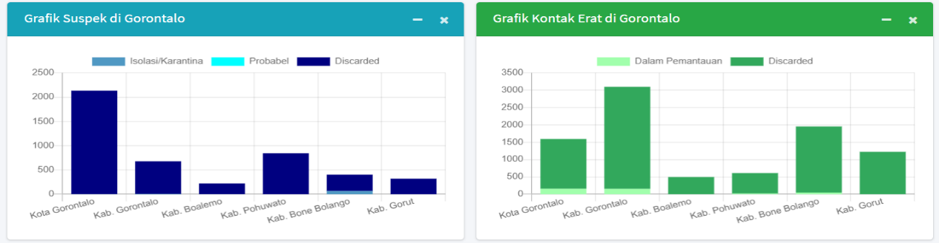
Grafik. 1Covid-19 outbreak InProv. Gorontalo
Source: Gorontalo Provincial Health Office in 2021.

Based on the data above, it is seen that the largest number of suspected cases in Gorontalo Province is in Gorontalo city, this shows that the city of Gorontalo contributes the largest number in terms of transmission and potential spread of Covid 19, so the enforcement of health protocols with you perwako needs to be very important to be echoed and massive gehis friend, because otherwise, Then there could be a new case in the spread of Covid 19 in the city of Gorontalo, especially now that Indonesia is facing the second wave of Covid 19 spread with the entry of a new variant, namely Delta B. 1925.
The problem is how effective is the implementation of the Gorontalo Mayor's regulations on the Implementation of Discipline and Law Enforcement of Health Protocols as an Effort to Prevent and Control Corona Virus Disease 2019 in the City of Gorontalo?
- Method
The type of research used by researchers in compiling this research is a type of normative-empirical research. In this research, the research approach methods used by researchers includecase approach andlaw approach. The data analysis technique used in this study is descriptive analysis with more description of the results of interviews, observations, and documentation studies.
- Analysis or Discussion
3.1 Effectiveness of The Implementation of Gorontalo Mayor's Regulation on The Implementation of Discipline and Law Enforcement of Health Protocols as An Effort to Prevent and Control Corona Virus Disease 2019 in Gorontalo City
Although still part of society's disease, COVID-19 has exceeded the limit. COVID-19 is highly contagious and spreads rapidly.This is reinforced by a potentially long incubation period and the potential for transmission of a person even though he or she shows no symptoms. The virus has also remained alive on surfaces such as paper and plastic for some time, and this could also be a potential area for the further spread of the virus. Due to the combination and the above factors, along with the widespread travel of a person or individual and product, the virus has spread globally and become a pandemic. Although most are asymptomatic or have mild symptoms, they can still be fatal, especially the elderly, sick, and those with certain conditions or diseases.Become very susceptible, and can also cause severe disorders or effects in the short and long term although the extent of these disorders or effects should still be fully understood. The combination of the nature of the infectious virus and the rate of infection of a person and contagious is certainly very worrying. It can also lead to the emergence of new clusters in several industries, including in health and other keyareas.
Coronavirustransmission in Indonesia is most likely to come from imported cases. Restrictions on mobility, especially from countries that have high case rates are indispensable. Recorded from data from the Central Statistics Agency or BPS, the number of foreigners in the first quarter of 2020 has a high number. BPS noted, from January to March 2020 there were 2.6 million foreign visitors in Indonesia, although it said the number had dropped by 31 percent. COVID-19 was declared to have spread in Southeast Asian countries in January 2020, although there have been no positive cases of Indonesian citizens infected, this also led to arguments that one of them cornered the Indonesian government which was considered incompetent to conduct tests or initial steps against exposure to COVID-19, with one of the statements issued by the Australian government and one of the professors from Harvard University, Although the Indonesian government finally firmly denied the statement.
The first confirmed positive case of COVID-19 in Indonesia came from two Indonesian citizens or Indonesian citizens residing in Depok, West Java. Both Indonesians tested positive for COVID-19 after they had a history of interacting with Japanese citizens who were known to have contracted the virus first. The findings of the first COVID-19 case in Indonesia were acknowledged and confirmed by President Joko Widodo at his press conference on Monday, March 2, 2020, in Jakarta. In addition, after getting the information, the Minister of Health, Terawan Agus Putranto said that the Indonesian Government will directly handle the search for the journey of the two Japanese nationals who turned out to have traveled to Indonesia.
Corona Virus Disease 2019 seen from this new virus cluster is declared contagious with another meaning if a person has been infected then he can also make others infected. The concept of infectious diseases includes acute or chronic which refers to the term acute to "fast" or in other words called "infection", where an immune condition in the human body is relatively fast to eliminate pathogens in a short time in a matter of days to weeks.Various parties conduct research and studies on how this virus works and spread so quickly from human to human and cause many victims, positive or dead. Unfortunately, since January when the new coronavirus was announced to be contagious between humans and has spread in various countries other than Wuhan, China, the Indonesian government responded slowly and indirectly to restrictions on direct air transportation access from Wuhan around six airports in Indonesia.
The spread of Covid-19 almost affects all aspects of life in Indonesia, but only health problems, but all vital aspects of nationality are also affected by the influence of Covid 19. Therefore, various responses prepared by the government in handling Covid-19 have been prepared for example related to the readiness of health facilities and infrastructure, and other readiness. One of the things that are also very important in the process of handling covid-19 is the readiness from the legal side because everything or government policy in handling covid-19 must have a legal basis therefore covid-19 also affects the legal dimension in the country of Indonesia.
The influence of the spread of Covid-19 in the field of law is characterized by the issuance of various legal rules. Such as Government Regulation No. 21 of 2020 on Large-Scale Social Restrictions, Regulation of the Minister of Health No. 9 of 2020 on Guidelines for Large-scale Social Restrictions, and Presidential Instruction No. 6 of 2020 on Discipline and Law Enforcement of Health Protocols in the Prevention and Control of Covid-19, which are the implementation of Law No. 6 of 2018 on Health Quarantine. The purpose of the issuance of various rules by the government is a manifestation of the seriousness of the Indonesian government to distribute Covid-19 experienced by almost all countries in the world. The legislation that has been issued by the government is an instrument to prevent and break the chain of the spread of Covid-19 in Indonesia. In this regard this amid the spread of Covid-19 there is a political party that must be implemented by the Indonesian nation as a democratic nation and upholds the political rights of its people to choose their leaders,in any situation, including in the Covid-19 pandemic situation.
On April 9, 2020, Governor Hi. Rusli Habibie announced that one of the residents contracted the coronavirus, as a form of response to national legal policies that will be followed up by the local government, Gorontalo province responded by issuing a request for large-scale social restrictions (PSBB) to the Minister of Health, through letter number: 44/Bappeda/45V/IV/2020. The official implementation of PSBB Gorontalo is marked by the approval of the implementation of PSBB in Gorontalo through the Decree of the Minister of Health of the Republic of Indonesia Number HK.01.07 / MENKES / 279/2020 on April 28, 2020. Then by the Governor of Gorontalo followed up with Gorontalo Regulation No. 15 of 2020 and Decree of the Governor of Gorontalo No. 152/33/V/2020 on the Implementation of PSBB In Handling Covid 19 in Gorontalo province. With the agreement of the Governor's PSBB following up with theGovernor'sletter Decision, the purpose of the PSBB is to prevent the spread of the virus even greater.
PSBB is regulated in the Regulation of the Minister of Health (Permenkes) Number 9 of 2020 on PSBB Guidelines in the framework of handling coronavirus diseases 2019 (Covid-19). In the Decree, it is mentioned that PSBB is a restriction of certain activities for residents in one area suspected of being infected with the coronavirus. The goal is to prevent the spread of the coronavirus even more. In Article 2 of the Decree, it is mentioned that a new territory can be designated in the status of PSBB if it has these two points: First; The number of cases and/or the number of deaths from the disease is increasing and spreading significantly and rapidly to several regions, Second; There are similarities in terms of patterns of disease spread with other regions orcountries.
The policy of the Gorontalo Provincial Government in handling COVID-19 is:
            - Circular Guidelines for preparedness to deal with COVID-19;
            - Circular adjustment of working hours;
            - Corona Virus Prevention Follow-up Circular on Tourism TaskForce;
            - SK Cluster COVID19;
            - Decree establishing emergency alert status;
            - Governor Gorontalo's Circular Letter On Prevention of Corona Virus Diseases;
            - The Governor's Circular letter for forkompindaelements;
            - Circular Letter of adjustment of Employee PerformanceSystem; and
            - Gorontalo Entrance CircularLetter.
In addition, to tighten the prevention of the spread of Covid-19, it is necessary to strengthen the power and efforts to adhere to the implementation of health protocols, the Governor of Gorontalo Province issued Gubemur Regulation No. 41 of 2020 on the Implementation of Discipline and Law Enforcement protocol Health as an effort to prevent and control Corona Virus Disease (Covid-i9) (Gorontalo Provincial News of 2020 Number 41).
The issuance of the Governor's Regulation as a concrete interpretation of the rising number of coronavirus spread in Gorontalo Province is based on data submitted by the Spokesman of the COVID-19 Task Force of Gorontalo Province, Dr. Triyanto Bialangi, said the increase in the number of positive cases in the province in the last two days caused Bone Bolango Regency and Gorontalo City to be declared red zones or areas with a high risk of transmission. According to him, on June 21, 2021,66 people were confirmed positive for COVID-19 based on the results of the PCR(polymerase chain reaction)examination. Cumulatively, the total number of COVID-19 cases in the province stands at 5,690 people, 183 of whom died. Triyanto further explained that there arecurrently a total of 148 people who are still being treated. Details, 51 people undergo self-quarantine; 38 under quarantine by the Gorontalo Provincial Government, 35 people in quarantine at the Education Quality Assurance Agency (LPMP) in Bonebolangi Regency; And 48 people were hospitalized.Here is data on the spread of Covid-19 in several districts and cities in Gorontalo Province:
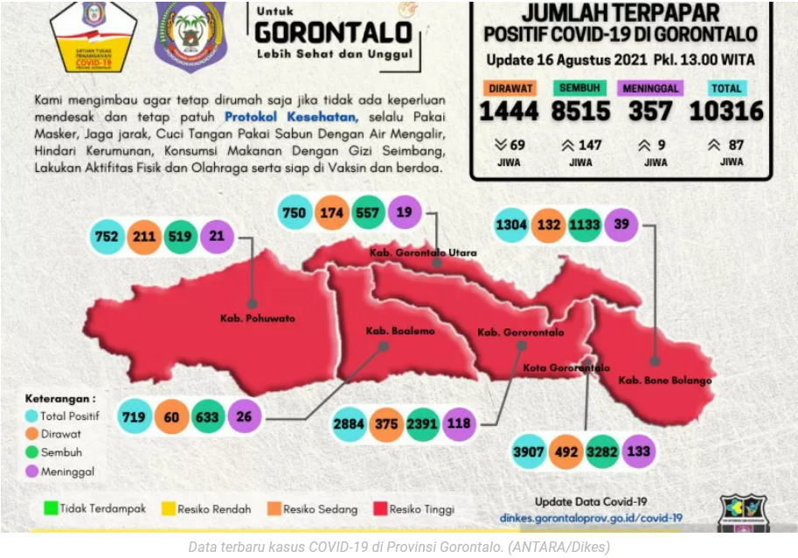
Picture. 1. Spread of Covid-19 virus in Prov. Gorontalo
The above data shows that the case of the spread of Covid-19 in Gorontalo Province is still fluctuating, which based on the publication of follow-up data submitted by the Gorontalo Provincial Covid-19 Task Force, that on August 16, 2021, there were 87 new cases in Gorontalo Province, fluctuating data on the spread of covid-19 in Gorontalo Province was influenced by the inaccuracy of the community in implementing health protocols strictly, This is based on direct confirmation delivered by the Head of Gorontalo Provincial Health Office, Yana Yanti Suleman.
While the latest dataupdate dated Tuesday, September 07, 2021, the addition of covid in Indonesia again experienced growth with a positive signal which means, seen the spread of the covid-19 virus in most parts of Indonesia began to rise again. There were 30 provinces with positive additions to covid-19 greater than the previous day and 5 other provinces with a smaller number of additions. Even compared to previous days, yesterday the daily growth rate was also high. A total of four provinces recorded the highest daily growth with a figure above 200 percent. These areas are Southeast Sulawesi, Gorontalo, West Kalimantan and Gorontalo City. Recorded for the four provinces, per yesterday's data provided an average of115.5 positive confirmed additions of covid-19 as many as 115.5 people in Southeast Sulawesi with a positive confirmed addition of 35 people. The previous day in the province only reported five people.More will be described in the table below:
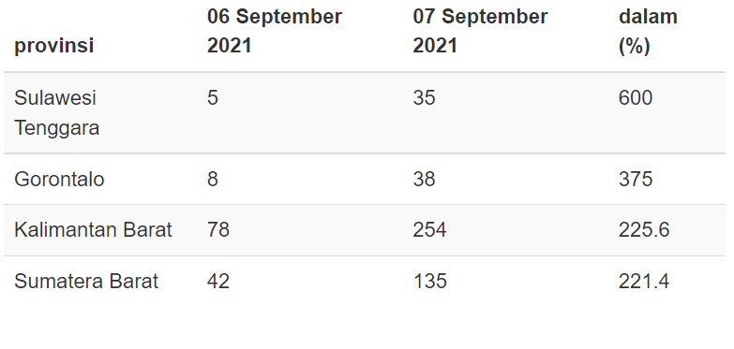
Table 1. Latest data updates on Covid-19 spread
From the data above, that Gorontalo Province is second with an additional number of 38 people. In percentage terms, the growth of positively confirmed additions in this place touched 375 percent. As for the highest number of data that has occurred in the last month, namely on Tuesday, August 10, 2021, at 207 people. In Gorontalo, the number of covid-19 cases was recorded at 11,385 positive people and 1,219 people are still in treatment. Of these regions, the positive population of covid-19 according to the largest age group is those between the youth age (19-30 years) 3,430 people.
In the number of Covid-19 spread in Gorontalo Province one of the largest numbers in the city of Gorontalo, therefore, as a form of response to the spread of Covid-19 in Gorontalo City, the Gorontalo City Government-issued Gorontalo Mayor Regulation No. 26 of 2020 on the Implementation of Discipline and The Law of Health Protocols as An Effort to Prevent and Control Corona Virus Disease 2019 (Covid-19) in Gorontalo City, that in order to carry out Presidential Instruction No. 6 of 2020 on Improving Discipline and Enforcement of Health Protocols in the Prevention and Control of Corona Virus Disease 2019 and Instruction of the Minister of Home Affairs No. 4 of 2020 on Technical Guidelines for The Regulation of Regional Heads in the Framework of The Implementation of Discipline and Law Enforcement protocol Health as An Effort to Prevent and Control Corona Virus Disease 2019 in the Region, it is necessary to establish the Gorontalo Mayor's Regulation on the Implementation of Discipline and Law Enforcement of Health Protocols as an Effort to Prevent and Control Corona Vims Disease 2019.
In the Mayor city Regulations as stated by the above researchers, in Articles 3 letters a, b, and c it is explained that the subjects in this regulation are to include:
              - Individual (doing 4M is wearing a mask, washing hands to keep a distance and avoid crowds);
              - Business actors, (preparing 4M facilities and infrastructure for employees and visitors who come); and
              - Managers, organizers, or accountable public places and facilities (preparing 4M facilities and infrastructure for employees and visitors who come).
Then in Article 4, it is classified that the subject of the arrangement as referred to in Article 3 shall implement and comply with the protocol of health, among others, including:
  - for individuals:
- using personal protective equipment in the form of a mask that covers the nose and mouth to the chin, if you have to leave the house or interact with others whose health status is unknown;
- regular hand washing using soap with running water and/or using hand sanitizer;
- physicallimitations (physical distancing); and
- Increase endurance by implementing Clean and Healthy Living Behaviors (PHBS).
  - for business people, managers, organizers, or people in charge of places, and public facilities:
- socialization, education, and use of various information media to provide understanding and understanding about the prevention of Covid-19 control;
- provision of handwashing facilities using soap that is easily accessible and completes the standard or provision of hand sanitizer (hand sanitizer);
- identification efforts (screening and monitoring of health for everyone who will be active in the work environment;
- keep the distance;
- regular cleaning and disinfection of the environment;
- Enforcement of discipline on the behavior of people who are at risk in the transmission and contracting of Covid-19; and
- Facilitation in early detection and case handling to anticipate the spread of Covid-19.
Based on Gorontalo Mayor's Regulation No. 26 of 2020 concerning the Implementation of Discipline and The Establishment of Health Protocol Law as an Effort to Prevent and Control Corona Virus Disease 2019 (Covid-19) in Gorontalo City, all parties must take a role in the implementation of health protocol enforcement consistently to reduce the number of the spread of Covid-19 Virus in Gorontalo City, because until Gorontalo City becomes one of the largest contributors to the spread of Covid-19. In Gorontalo Province, tidal apart from the publication of data submitted by the Gorontalo City Covid-19 Task Force Team which Until now, the spread of coronavirus in Gorontalo City is quite high, here is data on the spread of coronavirus 2019 (covid-19) in the city of Gorontalo:
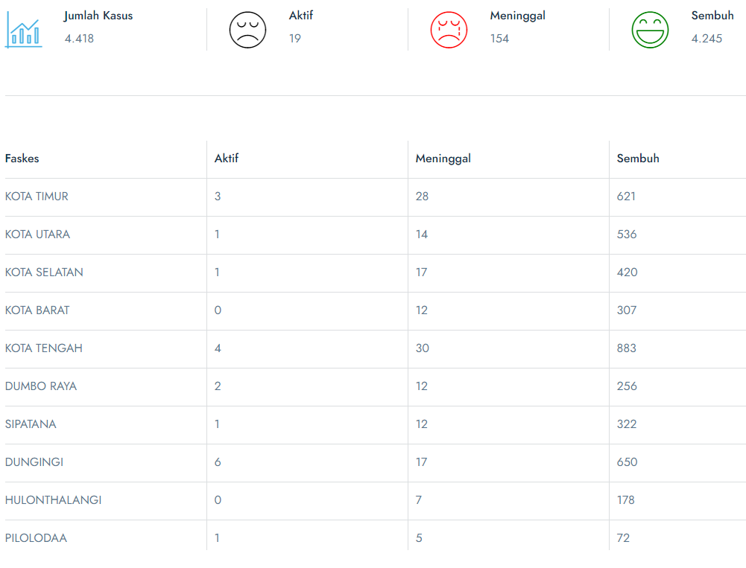
Table 2. Covid-19 Patients of Gorontalo City
Source: Gorontalo City Covid-19 Task Force
Based on the data above, the researchers saw that the case that occurred in the city of Gorontalo could not be separated from the violation of the Health protocol as one of the early rarities in preventing the spread of the virus, this is based on the findings of researchers When looking at existing conditions in terms of the application of health protocols that occur amid community interaction in everyday life, Moreover, related to activities in public spaces, there are still many who violate health protocols and of course also violate the provisions of Gorontalo Mayor's Regulation No. 26 of 2020 concerning the Implementation of Discipline and The Law of Health Protocols as an Effort to Prevent and Control Corona Virus Disease 2019 (Covid-19) in Gorontalo City.
Based on data compiled by researchers, researchers see that the implementation of the Perwako mandate on the Implementation of Discipline and Law Enforcement of Health Protocols as an Effort to Prevent and Control Corona Vims Disease 2019 has not been very effective, this is based on the release of data published by the Gorontalo Provincial Covid-19 Task Force which shows that the number of boxes is closely located in Gorontalo by district and city with positively confirmed people where This virus can be transmitted easily through contact with sufferers. This can be seen from the data below:
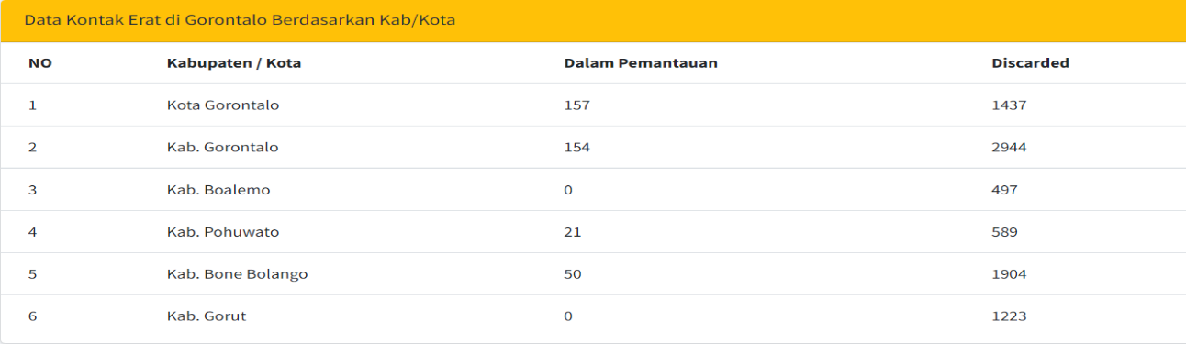
Tabel. 3 Close Contact Data
Source: Gorontalo Province Covid-19 Task Force
Based on the data above that the city of Gorontalo is one of the areas in Gorontalo Province that has a sufficient level of close contact, this is of course influenced by disobedience to the Health protocol. This is evidenced by the provision of social sanctions to 532 health protocol violators in Gorontalo City both individuals and business entities, who netted operations by the joint apparatus involving The Gorontalo City Satpol-PP, TNI, and Polri," said Gorontalo Mayor Marten A. Taha, after leading the Apple Integrated Team of The Covid-19 Health Protocol Disciplinary Raid in the courtyard of the Gorontalo Mayor's Office.
One of the cases of violations of the Health Protocol that also had put the Gorontalo City government in the spotlight was the activities of the Election Supervisory Agency (Bawaslu) Award held at the grand hotel of Gorontalo City, where the Gorontalo City Police Chief of AKBP Desmont Harjendro Aniston Putra together with the Gorontalo City Task Force Team forcibly disbanded the activities of the General Election Supervisory Agency (Bawaslu), In addition, the Gorontalo City Police Chief accompanied by the Bnpb Cadis of Gorontalo City and the Gorontalo City Police Chief gave a rebuke to the organizing committee of the event and the hotel because the implementation of the activity did not comply with the health protocol (Prokes) COVID-19.Researchers then confirmed the truth to the truth related to the activities organized by Bawaslu, the Gorontalo City Police Department, where the answer was found, that at the time the activity took place, the Police Chief said he did not want the activity to make the spread of COVID-19 increasing and become a new cluster.
In addition, based on data obtained by researchers, it was found that based on the results of joint operations from the Police, TNI, and Satpol PP in Gorontalo Province managed to secure 1,432 health protocol violators. That number netted from 51 operations at hundreds of points from September 4 to November 19, 2020, in Gorontalo city.It further said that currently, the joint officers focus on carrying out tiered enforcement, ranging from oral sanctions, written, social work to fines. It also already has a database of individual offenders who if violated again will be penalized with a fine.
The provision of sanctions as stipulated in the mayor's regulations is also equipped with the threat of fines for health protocol leaders as contained in article 7 paragraph 2 which states that sanctions violations the implementation of health protocols in the prevention and control of Covid-19 as referred to in paragraph (1) in the form of:
- For individuals:
- Verbal reprimands and written reprimands;
- Social work; and/or
- Administrative fine Rp.150,000.00 (one hundred and fifty thousand rupiahs).
- For business people, managers, organizers, or people in charge of places, and public facilities:
- Verbal reprimands and written reprimands;
- Administrative fine of Rp. 500,000.00 (five hundred thousand rupiahs);
- Temporary suspension of business operations; and/or
- Revocation of business license.
Related to the crackdown on restaurants, coffee shops, and other public facilities that violate health protocols, the joint apparatus has given warnings through the city task force which provides warnings to 47 restaurants, coffee shops, and other public facilities that violate health protocols. If the next opportunity is still negligent to health protocols, it will be sanctioned in the form of a fine of Rp. 500,000 thousand until the revocation of business licenses, of which of the 47 restaurants, coffee shops, and other public facilities that violate health protocols that are fined are15.
Furthermore, regarding the implementation of the Gorontalo Mayor's Regulation on the Implementation of Discipline and Law Enforcement of Health Protocols as an Effort to Prevent and Control Corona Vims Disease 2019 specifically in the village of Lokabalo where researchers lived based on the results of an interview with the Lurah Lekobalo Village of Gorontalo City, regarding the application of the mayor's regulations, according to the Lekobalo Village Lurah, that:
“From the enactment of curfews carried out by each village, in the village of lekobalo between August-October has followed up 52 riders and 3 times dispersed the crowd (hajatan / event arisan) if you want to perform the prayer is only allowed during the day is prohibited to carry out a night reception".
Thus, the researchers concluded that until the time of application to the Gorontalo Mayor's Regulation on the Application of Discipline and Law Enforcement of Health Protocols as an Effort to Prevent and Control Corona Vims Disease 2019 has not been fully effective, this is of course taking into account various data and based on direct tracing by researchers through interviews with several parties, One of them is the gorontalo city covid-19 task force, where in the search process found various problems that make this mayor's regulations not work effectively, especially after mass vaccination efforts carried out in the city of Gorontalo, where the public considers that post-vaccine, there is no need to apply protocol principles such as wearing masks, maintaining distance, and washing hands, It is also recognized directly by Lurah Lekobalo West City Subdistrict, Gorontalo City and Head of Covid-19 P2PL Control Affairs gorontalo City Health Office, that between 2020 and mid-2021 the community is still quite compliant, but after the vaccination rate looks high it looks like the public began the bodo period against health protocols, starting many underestimated the use of masks. People assume that after vaccination they will not be infected with the virus. So the obstacle to the enforcement of this rule is the lack of education to the public on the importance of health protocol enforcement.
- Conclusion
That the effectiveness of the implementation of Gorontalo mayor regulations on the implementation of discipline and law enforcement of health protocols as an effort to prevent and control coronavirus disease 2019 is still not able to effectively prevent the transmission and spread of covid-19 in the city of Gorontalo.
- Recommendations
- It is expected that every policy made by the Gorontalo City Government can be effectively socialized to the community so that the public knows and participates in the success of the policy.
- There needs to be consistency in the implementation of policies made by the Gorontalo City government, not just arriving when the moment comes of reason, or just making policies that are not supported by policy implementers and budgets, resulting in this policy being ineffective.

References
Book:
Alifah Kanza Widayati, et.all, Meningkatkan Kesadaran Masyarakat Untuk Memeatuhi Protokol Kesehatan Di ErA New Normal Dengan Media Poster Melalui Wagram (Whatsapp Dan Instagram), Universitas Negeri Semarang, 2020.
Dinas Kesehatan Provinsi Gorontalo. Laporan Akuntabilitas KinerjaDinas Kesehatan Provinsi Gorontalo (LAKIP)Program Pencegahan Dan Pengendalian Penyakit Satker Dekonsentrasi 05. (Gorontalo: Dinkes Of Gorontalo Province, 2020).
Gani, N. S., Fitriana, A. D., Sila, A. M., Fitriani, R., Yuliarti, A., Thalib, F., dan Umar, N. J. Covid 19 Dalam Bingkai Komunikasi. (Pare-Pare: IAIN Parepare Nusantara Press, 2020).
Rizqya, Safira Nur. Dampak kebijakan Publik Pembatasan Sosial Berskala Besar (PSBB) terhadap Hak konstitusional warga negara saat krisis Pandemi COVID-19. Diss. UIN Sunan Ampel Surabaya, 2021.
Sulana, Mahzar, Lilis Kurniati, and Ahmad Haerul Azizi. "Persepsi Masyarakat Terhadap Vaksinasi Covid-19 Di Provinsi Banten (Sebuah Penelitian di Daerah Kab. Serang, Kab. Pandeglang, dan Kab. Tangerang)." (2021).
Journal article:
Diah Handayaniet.all, Penyakit Virus Corona 2019, Jurnal Respirologi Indonesia (official Journal of The Indonesian Society of Respirology), Vol.40, No.2, 2020.
Fathin, Muhammad Hisyam, and Suyadi Suyadi. "Pengaruh COVID-19 dalam Fikih Ibadah Perspektif Neurosans: Studi Kasus Shalat Jum'at Shaf Berjarak 1m di Masjid Sunan Kalijaga." Nur El-Islam: Jurnal Pendidikan Dan Sosial Keagamaan 7.2 (2020).
Hulondalo.id. 2020. Polda Gorontalo sudah 13.169 kali bubarkan Kerumunan Massa selama pandemic, diakses dari https://hulondalo.id/polda-gorontalo-sudah-13-169-kali-bubarkan-kerumunan-massa-selama-pandemi/. Accessed June 20, 2021.
Ikfina Chairani, Dampak Pandemi Covid 19 Dalam Prespektif Gender Di Indonesia, Jurnal Kependudukan Indonesia, Vol.39 No.42. Tahun 2020.
Mary Dobbs, National Governance of Public Health Responses in a Pandemic?European Journal of Risk Regulation, Vol. 11 No. 2 (2020)
Moch Halim Sukur et.all, Penaganan Pelayanan Kesehatan Di Masa Covid-19 Dalam Prespektif Hukum Kesehatan, Jurnal Inicio Legis Vol.1 No. 1 2020.
Nur Indah Fitriani, Tinjauan Pustaka Covid-19 Virologi, Patogenesis, dan Maninfestasi Klins, Jurnal Medika Malahayati, Vol. 4 No. 3, Program Studi Penddikan Dokter Fakulas Kedokteran Universitas Lampung, 2020.
Ririn Noviyanti Putri, Indonesia Dalam Menghadapi Pandemi Covid-19¸Jurnal Ilmiah Universitas Batanghari Jambi, Vol. 20 No.2 Tahun 2020.
Tomy Michael, ‘Korelasi Komunisme Dalam Demokrasi Di Indonesia’, Refleksi Hukum: Jurnal Ilmu Hukum, 1.1 (2016)

Internet:
Antara, 2021. Tambahan Kasus baru Covid-19 di Gorontalo Masih tinggi. Diakses dari: https://www.antaranews.com/berita/2331278/tambahan-kasus-baru-covid-19-di-gorontalo-masih-tinggi. Retrieved November 10, 2021.
Agus Dwi Darmawan. Update Covid-19, penambahan Harian 30 Provinsi Kembali dalam sinyal naik. Diakses dari: https://databoks.katadata.co.id/datapublish/2021/09/08/update-covid-19-penambahan-harian-30-provinsi-kembali-dalam-sinyal-naik. Retrieved November 10, 2021.
Dwi Hadya Jayani,"Origin of Corona EnteringIndonesia", metadata.co.id, May 22, 2020, accessed on August 27, 2021
Humas Pemrov. Gorontalo. 2020. 1.432 Orang Pelanggar Prokes di Gorontalo Siap Siap Didenda. Diakses dari: https://gorontaloprov.go.id/1-432-orang-pelanggar-prokes-di-gorontalo-siap-siap-didenda/. Retrieved November 7, 2021.
Subhan Sabu, 2020. Tak Patuhi Protokol Kesehatan, Polisi dan Tim Gugus Tugas Kota Gorontalo membubarkan Paksa Acara Badan pengawas Pemilihan Umum Award. Accessed from: https://daerah.sindonews.com/read/281456/193/tak-patuhi-prokes-polisi-dan-tim-gugus-tugas-kota-gorontalo-bubar-paksa-acara-bawaslu-award-1609020769. Retrieved November 10, 2021.
Yoanes Litha, 2021. Kasus Covid-19 Naik, Kabupaten Bone Bolango dan Kota Gorontalo Zona Merah. Diakses dari: https://www.voaindonesia.com/a/kasus-covid-19-naik-kabupaten-bole-bolango-dan-kota-gorontalo-zona-merah-/5939384.html. Diakses pada 10 Novenber 2021.
Zuchri Abdussamad, 2020. Meminimalisir Penyebaran Covid-19 dan Efektifitas PSBB. Diakses dari:https://iaingorontalo.ac.id/e-goverment-sebagai-strategi-dalam-meminimalisir-penyebaran-covid-19-dan-efektivitas-psbb/ accessed November 3, 2021.

Nur Indah Fitriani, Tinjauan Pustaka Covid-19 Virologi, Patogenesis, dan Maninfestasi Klins, Jurnal Medika Malahayati, Vol. 4 No. 3, Program Studi Penddikan Dokter Fakulas Kedokteran Universitas Lampung, 2020. Hal 194-195.
Ibid.
Ikfina Chairani, Dampak Pandemi Covid 19 Dalam Prespektif Gender Di Indonesia, Jurnal Kependudukan Indonesia, Vol.39 No.42. Tahun 2020. Hal 39.
Diah Handayaniet.all, Penyakit Virus Corona 2019, Jurnal Respirologi Indonesia (official Journal of The Indonesian Society of Respirology), Vol.40, No.2, 2020. Hal 121.
Ririn Noviyanti Putri, Indonesia Dalam Menghadapi Pandemi Covid-19¸Jurnal Ilmiah Universitas Batanghari Jambi, Vol. 20 No.2 Tahun 2020. Hal 706.
Moch Halim Sukur et.all, Penaganan Pelayanan Kesehatan Di Masa Covid-19 Dalam Prespektif Hukum Kesehatan, Jurnal Inicio Legis Vol.1 No. 1 2020. Hal 9
Alifah Kanza Widayati, et.all, Meningkatkan Kesadaran Masyarakat Untuk Memeatuhi Protokol Kesehatan Di ErA New Normal Dengan Media Poster Melalui Wagram (Whatsapp Dan Instagram), Universitas Negeri Semarang, 2020. Hal 3.
Sekretariat Gugus Tugas Percepatan Penanganan Covid-19, 2020)
Hulondalo.id. 2020. Polda Gorontalo sudah 13.169 kali bubarkan Kerumunan Massa selama pandemic, diakses dari https://hulondalo.id/polda-gorontalo-sudah-13-169-kali-bubarkan-kerumunan-massa-selama-pandemi/. Accessed June 20, 2021.
Mary Dobbs, National Governance of Public Health Responses in a Pandemic? . EuropeanJournal of Risk Regulation, Vol. 11 No. 2 (2020): 242
Ibid
Dwi Hadya Jayani,"Origin of Corona EnteringIndonesia", katadata.co.id, May 22, 2020, accessed on August 27, 2021
Rizqya, Safira Nur. Dampak kebijakan Publik Pembatasan Sosial Berskala Besar (PSBB) terhadap Hak konstitusional warga negara saat krisis Pandemi COVID-19. Diss. UIN Sunan Ampel Surabaya, 2021. Hlm.42-43
Sulana, Mahzar, Lilis Kurniati, and Ahmad Haerul Azizi. "Persepsi Masyarakat Terhadap Vaksinasi Covid-19 Di Provinsi Banten (Sebuah Penelitian di Daerah Kab. Serang, Kab. Pandeglang, dan Kab. Tangerang)." (2021). Pp10
Gani, N. S., Fitriana, A. D., Sila, A. M., Fitriani, R., Yuliarti, A., Thalib, F., dan Umar, N. J. Covid 19 Dalam Bingkai Komunikasi. (Pare-Pare: IAIN Parepare Nusantara Press, 2020), Pp112
Fathin, Muhammad Hisyam, and Suyadi Suyadi. "Pengaruh COVID-19 dalam Fikih Ibadah Perspektif Neurosans: Studi Kasus Shalat Jum'at Shaf Berjarak 1m di Masjid Sunan Kalijaga." Nur El-Islam: Jurnal Pendidikan Dan Sosial Keagamaan 7.2 (2020): 89-113.
Tomy Michael, ‘Korelasi Komunisme Dalam Demokrasi Di Indonesia’, Refleksi Hukum: Jurnal Ilmu Hukum, 1.1 (2016), 15–28. Pp21
Dinas Kesehatan Provinsi Gorontalo. Laporan Akuntabilitas KinerjaDinas Kesehatan Provinsi Gorontalo (LAKIP)Program Pencegahan Dan Pengendalian Penyakit Satker Dekonsentrasi 05. (Gorontalo: Dinkes Of Gorontalo Province, 2020), Pp. 4
Zuchri Abdussamad, 2020. Meminimalisir Penyebaran Covid-19 dan Efektifitas PSBB. Diakses dari:https://iaingorontalo.ac.id/e-goverment-sebagai-strategi-dalam-meminimalisir-penyebaran-covid-19-dan-efektivitas-psbb/ diakses pada 3 November 2021.
Ibid
Yoanes Litha, 2021. Kasus Covid-19 Naik, Kabupaten Bone Bolango dan Kota Gorontalo Zona Merah. Diakses dari: https://www.voaindonesia.com/a/kasus-covid-19-naik-kabupaten-bole-bolango-dan-kota-gorontalo-zona-merah-/5939384.html. Diakses pada 10 Novenber 2021.
Antara, 2021. Tambahan Kasus baru Covid-19 di Gorontalo Masih tinggi. Diakses dari: https://www.antaranews.com/berita/2331278/tambahan-kasus-baru-covid-19-di-gorontalo-masih-tinggi. Diakses pada 10 November 2021.
Agus Dwi Darmawan. Update Covid-19, penambahan Harian 30 Provinsi Kembali dalam sinyal naik. Diakses dari: https://databoks.katadata.co.id/datapublish/2021/09/08/update-covid-19-penambahan-harian-30-provinsi-kembali-dalam-sinyal-naik. Diakses pada 10 November 2021.
Ibid
See Gorontalo City Regulation No. 29 of 2020 concerning the Implementation of Displin and The Law of Health Protocol as An Effort to Prevent and Control Corona Virus Disease 2019 (Covid-19) in Gorontalo City.
The Joint Interview with the Gorontalo City Covid-19 Task Force was conducted on October 15, 2021.
Subhan Sabu, 2020. Tak Patuhi Protokol Kesehatan, Polisi dan Tim Gugus Tugas Kota Gorontalo membubarkan Paksa Acara Badan pengawas Pemilihan Umum Award. Accessed from: https://daerah.sindonews.com/read/281456/193/tak-patuhi-prokes-polisi-dan-tim-gugus-tugas-kota-gorontalo-bubar-paksa-acara-bawaslu-award-1609020769. Retrieved November 10, 2021.
Wawancara Bersama dengan Gugus Tugas Covid-19 Kota Gorontalo dilakukan pada 15 Oktober Tahun 2021.
Humas Pemrov. Gorontalo. 2020. 1.432 Orang Pelanggar Prokes di Gorontalo Siap Siap Didenda. Diakses dari: https://gorontaloprov.go.id/1-432-orang-pelanggar-prokes-di-gorontalo-siap-siap-didenda/. Retrieved November 7, 2021.
Data bersumber dari Tim Gugus Tugas Pencehagan dan pengedalian Covid-19 Kota Gorontalo.
The interview was conducted at the Lekobalo Village Office of The West City District of Gorontalo City together with Lurah Lekobalo Ibu, Santi Mohamad. The interview was conducted on October 20, 2021.
The results of the joint interview with Lurah Kelurahan Lekobalo and head of Covid-19 P2PL control affairs of Gorontalo City Health Office on October 28, 2021.

