**Impacts of Land Use on Runoff and Sediment Dynamics in Tropical Watersheds: A Case Study in Bogowonto Upper Watershed**

Nugroho Christanto-1,2; Afid Nur Kholis 3, M Anggri Setiawan 1,2 Dhruba Pikha Shrestha4

*1 Department of Environmental Geography, Faculty of Geography, Universitas Gadjah Mada*

*2 Center for Disaster Studies, Universitas Gadjah Mada*

*3 Germany*

*4 Faculty of ITC University of Twente, the Netherland*

|  |  |  |
| --- | --- | --- |
| **ARTICLE INFO** |  | **ABSTRACT** |
| **Article history:**  Received: ...............  Accepted: .............  Published: ...............  **Keywords:**  **Land use, runoff, sediment dynamic, SWAT, Hydrological Model, Bogowonto**  **Corresponding author:**  Nugroho Christanto  Email: [nchristanto@ugm.ac.id](mailto:nchristanto@ugm.ac.id)   |  |  | | --- | --- | | **Read online:** | | |  | Scan this QR code with your smart phone or mobile device to read online. | | Land use change in tropical regions has increased in recent decades. Environmental stress is rising in Java, Indonesia's most populous island. Food shortages forced land conversion and expansion. Land use change increases peak flows in humid tropical environment. During rainy season, this increases the likelihood of flooding while water storage declines during the dry season. Prioritizing research on integrated catchment hydrology is essential. This study aims to examine the relationship between land use towards runoff and sediment in a tropical climate. The focus is on the Bogowonto Upper Watershed, and the aim is to enhance our comprehension of this relationship through SWAT hydrological modelling. The SWAT model is capable of understanding hydrological processes at the scale of a watershed and allow researchers to analyze the impact of of land use on runoff and sediment dynamics. The sensitivity of the SWAT model parameters varies in the upper watershed of Bogowonto. The runoff sensitivity analysis shows that the result of the model increased by +62% with 50 % changes in CN value. Since the changes is exceeding 100% of the input, CN is deemed highly sensitive. Meanwhile, 50% changes in vegetation cover (land use) bring +50 per cent model result. Thus, vegetation cover is considered moderately sensitive. Slope, KSat, and bulk density are considered fairly sensitive, while AWC is slightly sensitive due to variations of around 50%. On the other hand, the sediment sensitivity analysis shows that the result of the model is +47% with a 50% increase in CN Value. Thus, CN for sediment modelling is moderately sensitive. An increase of 50% in vegetation cover (land use) input leads to a corresponding increase of +58% in the model output. The variables of slope, KSat, and bulk density are considered moderately sensitive to these changes, while AWC is relatively sensitive with changes of around 50%. The model was run between 2014-2019 and has shown excellent accuracy. The Nash-Sutcliffe Efficiency (NSE) is 0.82, the Root Relative Mean Square Error (RRMSE) is 0.43, the Coefficient of Determination (R2) is 0.83, and the Percent Bias (PBIAS) is 9.8. |
| **How to cite:**Last name, Initials. (Year). Article title. *Journal Name, Volume*(issue), page range. https://doi.org/xxxx | | |

1. **INTRODUCTION**

Tropical watersheds have a crucial role in the regulation of water supplies(Abbaszadeh et al., 2023), the preservation of biodiversity(D. M. Amatya & M. K. Jha, 2011; Zhao et al., 2024), and the maintenance of livelihoods for millions of people around the world. Nevertheless, these watersheds are encountering escalating stresses due to human activities, such as deforestation, agricultural growth, urbanization, and infrastructural development. The alterations in land use have a dramatic effect on hydrological processes, including the flow of water and the dynamics of erosion, which have substantial consequences for the health of ecosystems, the purity of water, and the socio-economic well-being of communities (Christanto et al., 2018, 2019; Sun et al., 2015; sunandar et al., 2014; Yustika et al., 2012; Zhao et al., 2024). This study aims to thoroughly investigate the effects of land use on the flow of water and the wearing away of soil in tropical watersheds. It will utilize the Bogowonto Upper Watershed case studies to support its findings.

Land use change is mainly caused by agricultural expansion, logging, and infrastructure development, significantly contributing to runoff and erosion in tropical watersheds (Abbaszadeh et al., 2023; Pereira et al., n.d., 2022; Rubio et al., 2022). Land use change causes soil instability (Christanto, 2008), intensifies water flow, and accelerates erosion (Asselman et al., 2003; Pandey et al., 2016; Setiawan et al., 2009; Zhang et al., 2017), resulting in soil degradation, reduced fertility (Harashina et al., 2003; Vadas & Powell, 2013), and silt buildup in water bodies. Rapid urbanization and infrastructure development in tropical watersheds lead to substantial alterations in the natural drainage patterns. It will lead to a rise in impermeable surfaces and a disturbance of the interconnectedness of ecosystems. Consequently, there is a substantial rise in runoff and erosion. Urban environments are susceptible to many issues, such as flash floods, stream channel erosion, and water quality degradation. These problems can endanger Purworejo City areas' infrastructure, property, and public health. Significantly, the relationship between land use, runoff, and sediment dynamics in Tropical Environments remains poorly comprehended. Thus, hydrological modelling assumes significance. This study aims to examine the relationship between land use towards runoff and sediment in a tropical climate. The focus is on the Bogowonto Upper Watershed, and the aim is to enhance our comprehension of this relationship through hydrological modelling.

1. **METHOD**

## Study Area

The Bogowonto Upper Watershed is situated in Central Java, Indonesia (Figure 1) (BBWS SO, 2019). The overall drainage basin covers an estimated size of 333,995 square kilometers. The yearly precipitation in the catchment typically fluctuates between 2500-3500 mm. The topography exhibits a combination of different types. However, due to its location in a hilly area, most of the catchment area is characterized by steep slopes. Figure 1 displays the geographical map of the research region. The majority of the catchment area is situated in regions with high elevations. Overall, the human-caused impacts on the Bogowonto Upper Catchments are moderate. However, the National Strategic planning for developing one of the tallest reservoirs in Indonesia and the development of Badan Otorita Borobudur may accelerate the development of this area. Thus, the Bogowonto upper watershed in the tropical area of Indonesia is optimal for hydrological modeling research.

Figure 1. Bogowonto Upper Catchment

* 1. *SWAT Hydrological Model*

SWAT utilizes physiographic and hydro-meteorological data to perform rainfall-runoff modeling (Arnold, Moriasi, et al., 2012). The digital elevation model (DEM) is essential for delineating watersheds and sub-watersheds (dos R. Pereira et al., 2016). To create hydrologic response units (HRUs), three specific types of maps are required: land use/land cover (LULC), slope (derived from digital elevation model), and soil data (Arnold, Kiniry, et al., 2012b, 2012a; Arnold, Moriasi, et al., 2012; Gassman et al., 2007; Neitsch et al., 2011). The DEMNAS was acquired for the present investigation. The accuracy of this Digital Elevation Model (DEM) has been evaluated by comparing it with other globally available DEMs. The DEMNAS dataset can be accessed with a resolution of 8.1 meters and covers the entire Indonesian region. This study employs satellite imagery from Landsat 8 2019, which has a spatial resolution of 15 meters, to examine land use and land cover (LULC). The DEMNAS data is obtained from the Indonesian Geospatial Agency (BIG). The soil data is obtained through soil collection and laboratory analysis, utilizing a pedogeomorphological approach. The SWAT approach incorporates physiographic and hydro-meteorological data to simulate the rainfall-runoff process. The digital elevation model (DEM) is essential for delineating watersheds and sub-watersheds. To create hydrologic response units (HRUs), three specific types of maps are required: land use/land cover (LULC), slope (derived from digital elevation model), and soil data.

The SWAT model is a process-based semi-distributed model capable of simulating the water dynamics within a watershed. When the watershed is divided into hydrologic response units (HRUs), the SWAT model is semi-distributed. On the other hand, SWAT is also a persistent model capable of simulating long-term processes. The research methods comprised three primary phases: pre-fieldwork, fieldwork, and post-fieldwork (including model simulation and analysis). Figure 2 shows the research flowchart. The pre-fieldwork and fieldwork stages are crucial as they significantly impact the success rate of the model simulation process. Thoroughly preparing for fieldwork will enhance the efficiency of data collection techniques and sampling procedures in the field.

Figure 2. Research flowchart

The main challenge through the pre-fieldwork and fieldwork phases is determining the most effective and efficient means of acquiring the required data for input into the model. The SWAT model and analysis were applied to runoff simulation and sediment yields during the post-fieldwork stage.

* 1. *Model Performance*

Model performance is evaluated using quantitative measurements such as graphic comparisons and statistical testing. An accuracy criterion can assess the agreement between predicted and observed outputs during calibration. Therefore, it is possible to determine the goodness of fit and the ideal parameter values for each set of parameters. The statistical measures used to compare the simulated and actual results were the coefficient of determination (R2), Nash–Sutcliffe efficiency (NSE) (equation 1) (Nash & Sutcliffe, 1970), and percent bias (PBIAS)(Motovilov et al., 1999; Schilirò et al., 2016) (equation 2). Sensitivity analysis can determine the various elements that influence model outputs and reactions. Statistical analysis (SA) also examines the correlations between parameters, the range of values that are preferred, and the variability across different regions, all of which impact the output of the model. Model performance is evaluated using quantitative measurements such as graphic comparisons and statistical testing. A criterion for accuracy can be used to compare the predicted and observed results during the calibration process. Therefore, it is possible to determine the goodness of fit and the ideal parameter values for each set of parameters. The model's performance was assessed by comparing the simulated and actual results using the coefficient of determination (R2), Nash-Sutcliffe efficiency (NSE) (equation 1), and percent bias (PBIAS) (equation 2). Sensitivity analysis is a method used to identify and quantify the different factors that have an impact on the results and responses of a model. Statistical analysis also investigates the relationships between parameters, their ideal range, and the variation across various locations, all of which influence the output of the model.

 (Equation 1)

PBIAS is a statistic that calculates the difference between observed and simulated data, as defined by Equation 1. The model demonstrates an overestimation, as indicated by a negative PBIAS value, which suggests that the simulated values are higher than the measured ones. In contrast, a positive PBIAS indicates that the simulation are lower than the observed value (Boyle et al., 2000; Gupta et al., 1999).

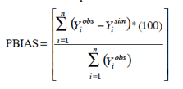 (Equation 2)

Sensitivity analysis is a tool used to evaluate the influence of input parameters on the output of a model. It is useful not only for developing and validating models, but also for reducing uncertainty (Hamby, 1994).Consequently, conducting a sensitivity analysis allows for a more comprehensive understanding of the input parameters that have a greater impact on the model's output.

1. **RESULTS AND DISCUSSION**
   1. *Sensitivity Analysis*

This paper aims to assess the effectiveness of a semi-distributed hydrological model (SWAT) in Bogowonto Upper Catchment in Central Java. This paper was conducted to evaluate the capability of SWAT hydrological modeling on a tropical watershed and determine the model's sensitivity to essential parameters. Model was performed during period of 2010-2013 for the calibration and 2014-2019 to assess the model performance. The curve number (CN) of the cultivated land in the research area significantly affected the river discharge and sediment outputs predicted by the SWAT model. Figure 50 demonstrates the significant impact of adjusting CN (crop) on discharge for all the watersheds, regardless of whether CN increases or decreases. Increasing CN value also substantially increases runoff, while decreases in CN will dramatically reduce the runoff. Runoff is inversely correlated with available water capacity (AWC), KSAT, bulk density, and soil depth. The study revealed that soil physical characteristics are crucial in determining runoff

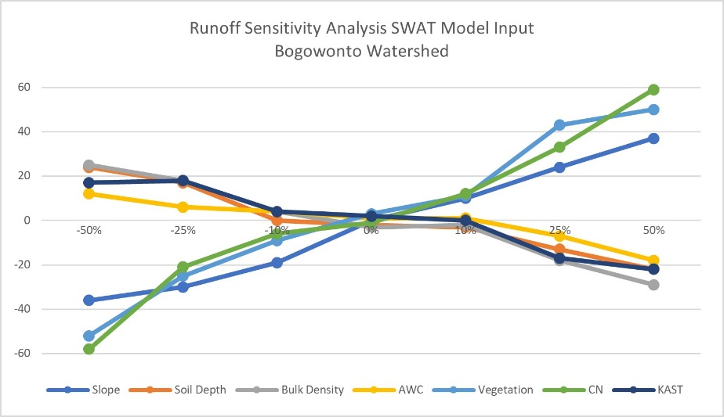

Figure 3. Parameter sensitivity analysis prior to runoff in Bogowonto Upper Watershed

Figure 3 demonstrates that the sensitivity of parameters in the SWAT model differs in the Bogowonto Upper watershed. By applying a 50% increase to each CN input, the model's outcome experiences a 62% increase. Due to the changes exceeding 100% of the input, CN is regarded as highly sensitive. The vegetation cover (land-use) increases by 50% when the input of changes is increased by 50%. Therefore, vegetation is regarded as moderately sensitive. Meanwhile, slope variables, KSat (saturated hydraulic conductivity), and bulk density exhibit a moderate level of sensitivity. At the same time, AWC (available water capacity) shows a modest level of sensitivity since the observed variations are approximately 50 percent.

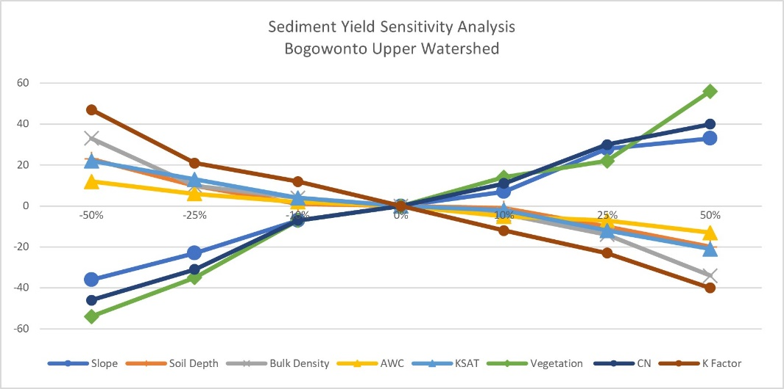

Figure 4. Parameter sensitivity analysis prior to sediment yield in Bogowonto Upper Watershed

The sediment yield sensitivity analysis shows a relatively similar pattern where CN, vegetation cover, and slope are more sensitive than soil depth, K Factor, bulk density, AWC, and KSAT, as shown in Figure 4. Increases in CN also significantly increase sediment yield, while decreasing CN will decrease the sediment yield significantly. Sediment yield is inversely proportional to available water capacity AWC, KSAT, bulk density, soil depth, and K Factor. Although the soil's physical parameters were found to be critical for sediment yield, the sensitivity was + 17% to 33%, with 59% percent input changes for all watersheds. This condition means that soil properties are generally slightly sensitive to moderate sensitive in sediment yield simulation. With an input of 50% on CN, the model shows increasing of 47 %. CN is considered moderately sensitive since the changes are less than 100% of the input. For the vegetation cover (land-use), the result of 50% changes in the result of changes shows the sediment increase by 58%. Thus, Vegetation is considered highly sensitive in all watersheds since the changes are more than 100%. At the same time, slope, KSat, and bulk density are moderately sensitive, and AWC is slightly sensitive since the changes are approximately 50%.

* 1. *Validation*

The evaluation of the model's performance indicates that the simulated discharge flows are being underestimated. This situation is indicated by the positive PBIAS values of 9.7, as reported by Gupta et al. (1999) and Moriasi et al. (2007). Figure 4 presents a comparison between the discharge flows derived from the Punggangan gauging station, both from simulations and observations. The model's performance indicates that it achieves outstanding outcomes. The analysis reveals the following values: NSE (Nash-Sutcliffe Efficiency) of 0.80, RRMSE (Root Relative Mean Square Error) of 0.42, R2 (Coefficient of Determination) of 0.82, and PBIAS (Percent Bias) of 9.7.

* 1. *Impact of Landuse on Runoff and Erosion*

The effect of land use on the hydrological response at the Upper Bogowonto catchment was analyzed individually based on land use. The analysis results showed that land use controls runoff. The impact of land use on runoff is shown in Figure 5. The model shows that settlement contributes to high runoff, followed by dryland agriculture and rice fields. Figure 5 shows that mixed gardens, shrubland, and forests contribute less to runoff than other land uses.

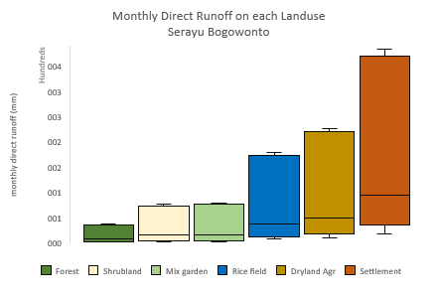

Figure **5**. Runoff on each land use in Bogowonto Upper Catchment

The estimates of the amount of surface runoff generated in the 47 sub-basins were classified into five surface runoff groups. Using the land-use maps 2019, the model was performed in 2014-2019, assuming no significant changes. Figure 6 shows that sub-basin 39 falls at class V with very high runoff. For class IV, the result shows in the sub-basin numbers 2, 16, 18, 23, 30, 34, 36, 43, and 47. The rest belong to classes I, II, and III. This condition prior to land use was dominant in the sub-basin area. Compared to Upper Serayu Catchment, the runoff on each sub-basin in Bogowonto Upper Catchment is better due to its land use. Figure 6 shows the runoff distribution on each sub-basin.

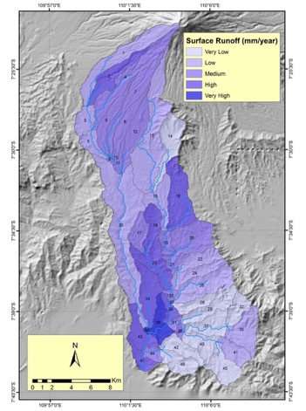

Figure 6. Runoff distribution on each sub-basin, Bogowonto Upper Cathment

Prior to sediment yield, the effect of land use on the sediment discharge response at the basin scale was assessed based on model simulation. The results of the analysis showed that the sediment is also controlled by land use. The impact of land use on the sediment is shown in Figure 7. The model shows that dryland agriculture contributes to high sediment discharge, followed by shrubland. From the simulation, we can understand that the rice field has a medium impact on sediment yield, while settlement, mixed gardens, and forests have a low contribution to sediment yield compared to other land uses.

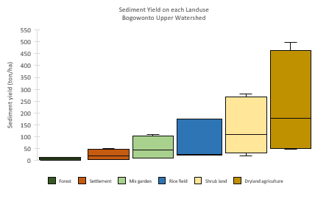

Figure 7. sediment yield in Bogowonto Upper Catchment prior to Landuse

The SWAT model was applied to estimate the amount of sediment generated from 47 sub-basins. The sub-basin sediment was classified into five surface runoff groups. Figure 8-a shows that sub-basin numbers 1,4,14, and 32 falls at class V with a very high sediment yield. For class IV, the result shows in the sub-basin of 2,13, 24, 29, and 39. The rest belong to classes I, II, and III. This condition prior to land use is dominant in the sub-basin area; they are dryland agriculture in classes IV and V. Figure 8 shows the sediment yield distribution on each sub-basin.

In terms of watershed management, HRU assessments were applied. The results of this study show that land use plays a dominant role in the sediment yield of the Upper Bogowonto Catchment. Figure 8-b shows the spatial distribution of sediment contribution prior to land-use distribution in the form of HRU. We learned that from the HRU, we can select priority areas to improve watershed response. The best management practice for watershed management is not solely applied based on sediment in the sub-basin but also considers HRU to perform a precise action toward watershed management.

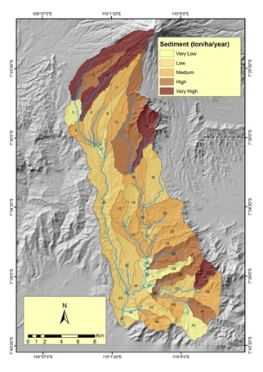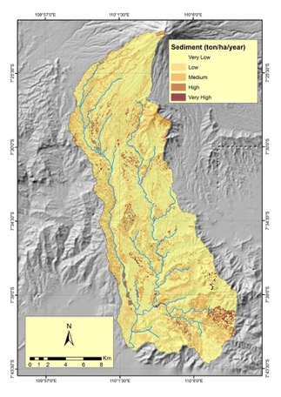

Figure 8 a. Sediment yield on each sub-basin, Bogowonto Upper Catchment,

b. Sediment yield based on HRU

1. **CONCLUSIONS**

This study investigates the correlation between land use and the occurrence of runoff and sediment in a tropical environment. The study's results demonstrate that land use significantly impacts runoff and sediment dynamics in the studied area. The Curve Number (CN) and vegetation cover are identified as highly sensitive parameters, while the soil physical parameter exhibits moderate to slightly sensitive characteristics. The findings also indicate that various land use practices influence the runoff and sediment. The analysis suggests that land use significantly impacts the amount of runoff. The relationship between land use and runoff reveals that settlements have the greatest impact on runoff, followed by dryland agriculture and rice fields. However, the model indicates that land uses such as mixed gardens, shrublands, and forests contribute less to runoff than other land types. The research shows that land use also influences sediment. According to the model, dryland agriculture significantly contributes to sediment discharge, with shrubland closely behind. Based on the simulation, we can conclude that the rice field moderately influences sediment yield. In contrast, housing, mixed gardens, and woodlands have a minimal impact on sediment yield compared to other land uses. The model's result clearly shows that the SWAT hydrological model is appropriate for hydrological simulation in tropical environments at a basin scale.

1. **REFERENCES**

Abbaszadeh, M., Bazrafshan, O., Mahdavi, R., Sardooi, E. R., & Jamshidi, S. (2023). Modeling Future Hydrological Characteristics Based on Land Use/Land Cover and Climate Changes Using the SWAT Model. *Water Resources Management*, *37*(10), 4177–4194. https://doi.org/10.1007/S11269-023-03545-6

Arnold, J. G., Kiniry, J. R., Srinivasan, R., Williams, J. R., Haney, E. B., & Neitsch, S. L. (2012a). *Soil and Water Assessment Tool: Input/Output Files*. http://swat.tamu.edu/media/69296/SWAT-IO-Documentation-2012.pdf

Arnold, J. G., Kiniry, J. R., Srinivasan, R., Williams, J. R., Haney, E. B., & Neitsch, S. L. (2012b). *Soil and Water Assessment Tool (SWAT) User’s Manual, Version 2012*. https://doi.org/10.1007/978-0-387-35973-1_1231

Arnold, J. G., Moriasi, D. N., Gassman, P. W., Abbaspour, K. C., White, M., Srinivasan, R., Santhi, C., Harmel, D., Griensven, A. van, Liew, M. Van, Kannan, N., & Jha, M. K. (2012). SWAT: Model use, calibration, and validation. *Biological Systems Engineering: Papers and Publications*.

Asselman, N. E. M., Middelkoop, H., & van Dijk, P. M. (2003). The impact of changes in climate and land use on soil erosion, transport and deposition of suspended sediment in the River Rhine. *Hydrological Processes*, *17*(16), 3225–3244. https://doi.org/10.1002/hyp.1384

BBWS SO, T. (2019). *Laporan TKPSDA WS Serayu Bogowonto*.

Boyle, D. P., Gupta, H. V., & Sorooshian, S. (2000). Toward improved calibration of hydrologic models: Combining the strengths of manual and automatic methods. *Water Resources Research*, *36*(12), 3663–3674. https://doi.org/10.1029/2000WR900207

Christanto, N. (2008). *Hydrological – Slope Stability Modeling for Landslide Hazard Assessment by means of GIS and Remote Sensing Data in Geo-Information for Spatial Planning and Risk Management*. https://www.itc.nl/library/papers_2008/msc/ugm/nugroho.pdf

Christanto, N., Setiawan, M. A., Nurkholis, A., Istikhomah, S., Anajib, D. W., & Purnomo, A. D. (2019). Rainfall-Runoff and Sediment Yield Modelling in Volcanic catchment using SWAT, a Case Study in Opak Watershed. *IOP Conference Series: Earth and Environmental Science*, *256*(1). https://doi.org/10.1088/1755-1315/256/1/012015

Christanto, N., Setiawan, M. A., Nurkholis, A., Istiqomah, S., Sartohadi, J., & Hadi, M. P. (2018). Analisis Laju Sedimen DAS Serayu Hulu dengan Menggunakan Model SWAT. *Majalah Geografi Indonesia*, *32*(1), 50. https://doi.org/10.22146/mgi.32280

D. M. Amatya, & M. K. Jha. (2011). Evaluating the SWAT Model for a Low-Gradient Forested Watershed in Coastal South Carolina. *Transactions of the ASABE*, *54*(6), 2151–2163. https://doi.org/10.13031/2013.40671

dos R. Pereira, D., Martinez, M. A., Pruski, F. F., & da Silva, D. D. (2016). Hydrological simulation in a basin of typical tropical climate and soil using the SWAT model part I: Calibration and validation tests. *Journal of Hydrology: Regional Studies*, *7*, 14–37. https://doi.org/10.1016/j.ejrh.2016.05.002

Gassman, P. W., Reyes, M. R., Green, C. H., & Arnold, J. G. (2007). *SWAT: Hystorical development, applications, and future research directions*. *50*(4), 1211–1250.

Gupta, H. V., Sorooshian, S., & Yapo, P. O. (1999). Status of Automatic Calibration for Hydrologic Models: Comparison with Multilevel Expert Calibration. *Journal of Hydrologic Engineering*, *4*(2), 135–143. https://doi.org/10.1061/(ASCE)1084-0699(1999)4:2(135)

Hamby, D. M. (1994). A review of techniques for parameter sensitivity analysis of environmental models. *Environmental Monitoring and Assessment*, *32*(2), 135–154. https://doi.org/10.1007/BF00547132

Harashina, K., Takeuchi, K., Tsunekawa, A., & Arifin, H. S. (2003). Nitrogen flows due to human activities in the Cianjur-Cisokan watershed area in the middle Citarum drainage basin, West Java, Indonesia: A case study at hamlet scale. *Agriculture, Ecosystems and Environment*, *100*(1–3), 75–90. https://doi.org/10.1016/S0167-8809(03)00173-7

Motovilov, Y. G., Gottschalk, L., Engeland, K., & Rodhe, A. (1999). Validation of a distributed hydrological model against spatial observations. *Agricultural and Forest Meteorology*, *98–99*, 257–277. https://doi.org/10.1016/S0168-1923(99)00102-1

Nash, J. E., & Sutcliffe, J. V. (1970). River flow forecasting through conceptual models part I — A discussion of principles. *Journal of Hydrology*, *10*(3), 282–290. https://doi.org/10.1016/0022-1694(70)90255-6

Neitsch, S. L., Arnold, J. G., Kiniry, J. R., & Williams, J. R. (2011). *Soil and Water Assessment Tool Theoretical Documentation Version 2009 Texas Water Resources Institute*. http://swat.tamu.edu/media/99192/swat2009-theory.pdf

Pandey, A., Himanshu, S. K., Mishra, S. K., & Singh, V. P. (2016). Physically based soil erosion and sediment yield models revisited. *CATENA*, *147*, 595–620. https://doi.org/10.1016/j.catena.2016.08.002

Pereira, P., Gomes, E., & Rocha, J. (2022). Mapping and Forecasting Land Use: The Present and Future of Planning. *Mapping and Forecasting Land Use: The Present and Future of Planning*, 1–325. https://doi.org/10.1016/C2020-0-02839-2

Pereira, P., Gomes, E., & Rocha, J. G. (n.d.). *Mapping and forecasting land use : the present and future of planning*.

Rubio, C., Rojas, F., Rubio, M. C., Sales, R., Rubio, F., Verdugo, L., Greco, G., & Martín, F. (2022). Drivers of land use and land cover changes in South America. A review focused on drylands. In *Mapping and Forecasting Land Use: The Present and Future of Planning*. Elsevier. https://doi.org/10.1016/B978-0-323-90947-1.00004-1

Schilirò, L., Montrasio, L., & Scarascia Mugnozza, G. (2016). Prediction of shallow landslide occurrence: Validation of a physically-based approach through a real case study. *Science of The Total Environment*, *569*, 134–144. https://doi.org/10.1016/j.scitotenv.2016.06.124

Setiawan, M. A., Stoetter, J., Sartohadi, J., & Christanto, N. (2009). *The Integrated Soil Erosion Risk Management Model of Central Java , Indonesia*. *11*.

Sun, L., Nistor, I., & Seidou, O. (2015). Streamflow data assimilation in SWAT model using Extended Kalman Filter. *Journal of Hydrology*, *531*, 671–684. https://doi.org/10.1016/j.jhydrol.2015.10.060

sunandar, ahmad dany, Suhendang, E., . H., Jaya, I. N. S., & . M. (2014). Land Use Optimization in Asahan Watershed with Linear Programming and SWAT Model. *International Journal of Sciences: Basic and Applied Research (IJSBAR)*, *18*(1), 63–78. http://gssrr.org/index.php?journal=JournalOfBasicAndApplied&page=article&op=view&path%5B%5D=2678

Vadas, P. A., & Powell, J. M. (2013). Monitoring nutrient loss in runoff from dairy cattle lots. *Agriculture, Ecosystems & Environment*, *181*, 127–133. https://doi.org/10.1016/J.AGEE.2013.09.025

Yustika, R. D., Tarigan, S. D., & Sudadi, U. (2012). SIMULASI MANAJEMEN LAHAN DI DAS CILIWUNG HULU MENGGUNAKAN MODEL SWAT. *Informatika Pertanian*, *21*(2), 71. https://doi.org/10.21082/ip.v21n2.2012.p71-79

Zhang, S., Fan, W., Li, Y., & Yi, Y. (2017). The influence of changes in land use and landscape patterns on soil erosion in a watershed. *Science of The Total Environment*, *574*, 34–45. https://doi.org/10.1016/j.scitotenv.2016.09.024

Zhao, J., Zhang, N., Liu, Z., Zhang, Q., & Shang, C. (2024). SWAT model applications: From hydrological processes to ecosystem services. *Science of The Total Environment*, *931*, 172605. https://doi.org/10.1016/J.SCITOTENV.2024.172605