Lampiran
Lampiran 1 Surat Keputusan Penetapan Proposal Penelititan Skripsi
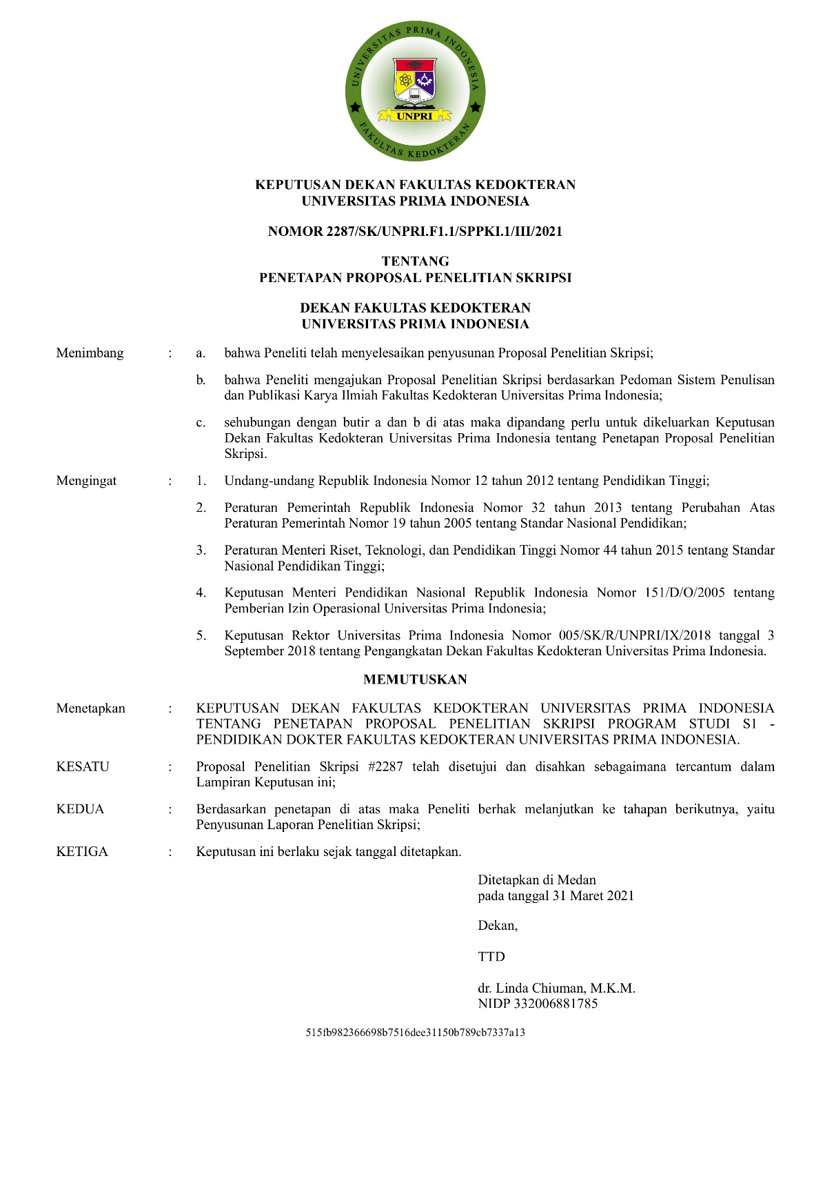

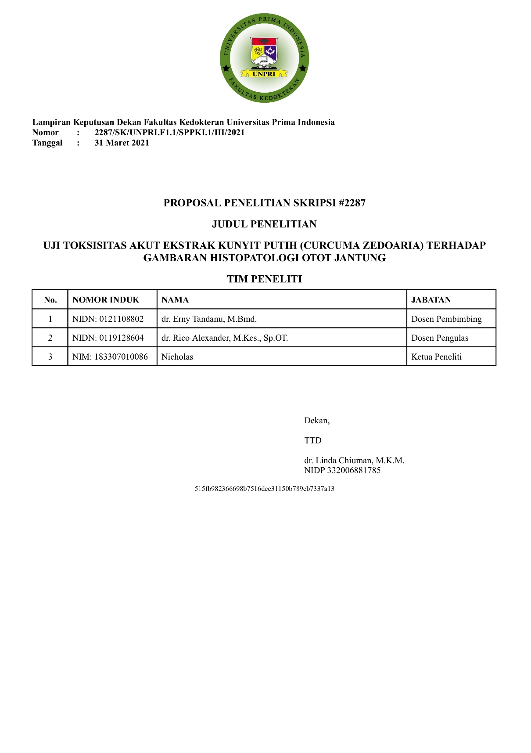

Lampiran 2 Surat Keterangan Layak Etik, dari Komisi Etik Penelitian Kesehatan (KEPK) Universitas Prima Indonesia
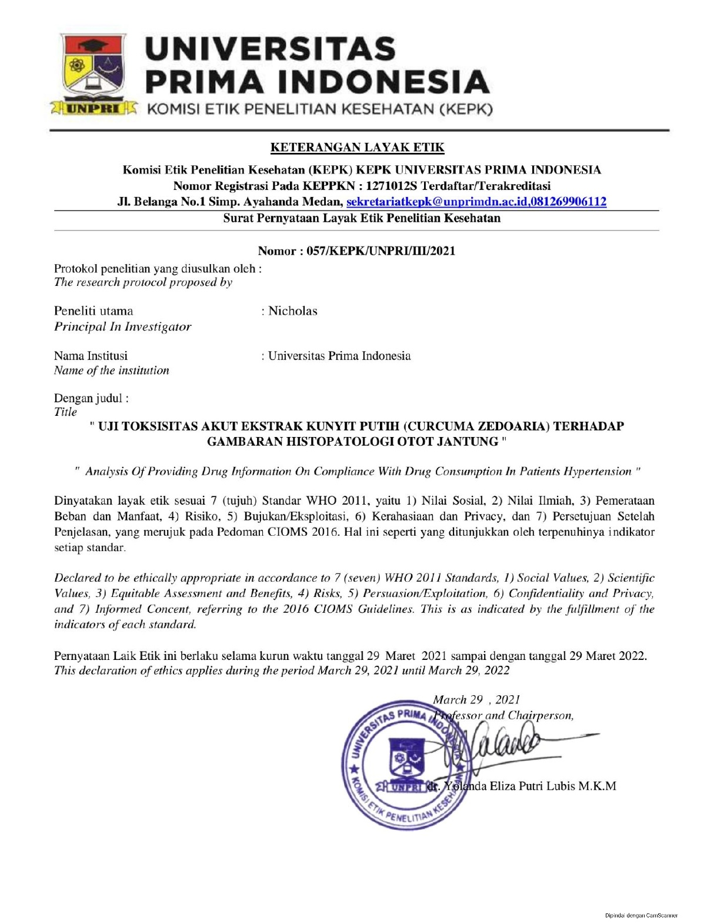

Lampiran 3 Dokumentasi Proses Penilitian
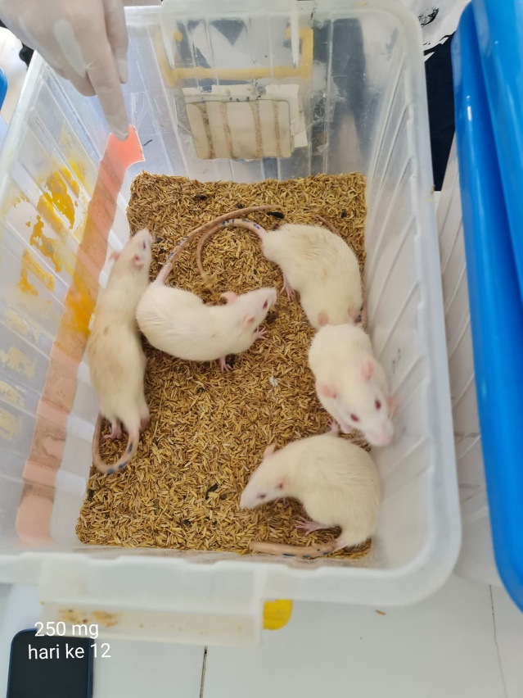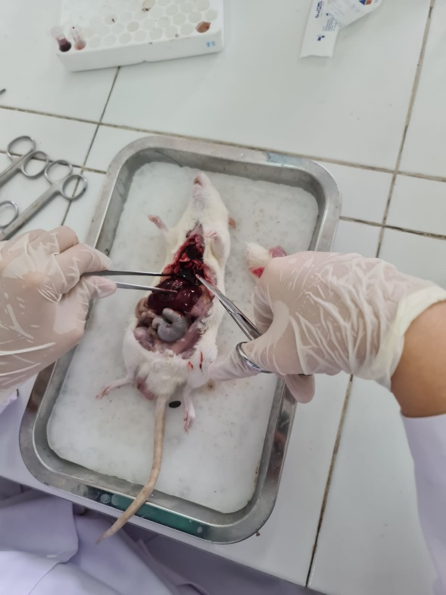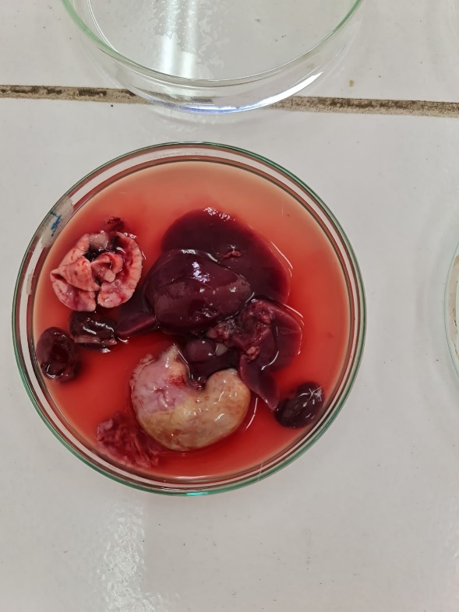

Lampiran 4 Hasil Uji SPSS
Uji Normalitas dan Uji ANOVA Histopatologi Jantung Tikus
Tests of Normality
 | Kelompok Tikus | Kolmogorov-Smirnovª |  |  | Shapiro-Wilk
 |  | Statistic | df | Sig. | Statistic | df | Sig.
Hiperemi | kontrol positif | .231 | 5 | .200* | .881 | 5 | .314
 | kontrol negatif | .349 | 5 | .046 | .771 | 5 | .046
 | 250 mg/KgBB | .141 | 5 | .200* | .979 | 5 | .928
 | 500 mg/KgBB | .250 | 5 | .200* | .862 | 5 | .234
 | 750 mg/KgBB | .246 | 5 | .200* | .956 | 5 | .777
 | 2000 mg/KgBB | .241 | 5 | .200* | .903 | 5 | .427
Hemoragi | kontrol positif | .473 | 5 | .001 | .552 | 5 | .000
 | kontrol negatif | .473 | 5 | .001 | .552 | 5 | .000
 | 250 mg/KgBB | .180 | 5 | .200* | .942 | 5 | .677
 | 500 mg/KgBB | .179 | 5 | .200* | .984 | 5 | .955
 | 750 mg/KgBB | .207 | 5 | .200* | .967 | 5 | .853
 | 2000 mg/KgBB | .127 | 5 | .200* | .999 | 5 | 1.000
Degenerasi | kontrol positif | .473 | 5 | .001 | .552 | 5 | .000
 | kontrol negatif | .349 | 5 | .046 | .771 | 5 | .046
 | 250 mg/KgBB | .368 | 5 | .025 | .700 | 5 | .010
 | 500 mg/KgBB | .223 | 5 | .200* | .915 | 5 | .497
 | 750 mg/KgBB | .146 | 5 | .200* | .992 | 5 | .985
 | 2000 mg/KgBB | .241 | 5 | .200* | .903 | 5 | .427
*. This is a lower bound of the true significance.
a. Lilliefors Significance Correction

ANOVA
 |  | Sum of Squares | df | Mean Square | F | Sig.
Hiperemi | Between Groups | 977.367 | 5 | 195.473 | 45.994 | .000
 | Within Groups | 102.000 | 24 | 4.250
 | Total | 1079.367 | 29
Hemoragi | Between Groups | 2226.300 | 5 | 445.260 | 83.226 | .000
 | Within Groups | 128.400 | 24 | 5.350
 | Total | 2354.700 | 29
Degenerasi | Between Groups | 2456.667 | 5 | 491.333 | 44.871 | .000
 | Within Groups | 262.800 | 24 | 10.950
 | Total | 2719.467 | 29

Uji Normalitas dan ANOVA Berat Jantung Tikus
Tests of Normality
 | Kelompok tikus | Kolmogorov-Smirnovª |  |  | Shapiro-Wilk
 |  | Statistic | df | Sig. | Statistic | df | Sig.
Berat Jantung | Kontrol negatif | .230 | 5 | .200* | .894 | 5 | .378
 | Kontrol positif | .280 | 5 | .200* | .845 | 5 | .179
 | 250 | .246 | 5 | .200* | .878 | 5 | .300
 | 500 | .169 | 5 | .200* | .992 | 5 | .988
 | 750 | .317 | 5 | .112 | .822 | 5 | .120
 | 2000 | .309 | 5 | .134 | .861 | 5 | .231
*. This is a lower bound of the true significance.
a. Lilliefors Significance Correction

ANOVA
Berat Jantung
 | Sum of Squares | df | Mean Square | F | Sig.
Between Groups | 65419.367 | 5 | 13083.873 | 1.417 | .254
Within Groups | 221604.000 | 24 | 9233.500
Total | 287023.367 | 29

Uji Normalitas dan Uji ANOVA Berat Tikus
Tests of Normality
 | Kelompok tikus | Kolmogorov-Smirnovª |  |  | Shapiro-Wilk
 |  | Statistic | df | Sig. | Statistic | df | Sig.
Berat tikus H-1 | Kontrol negatif | .240 | 5 | .200* | .946 | 5 | .709
 | Kontrol positif | .226 | 5 | .200* | .881 | 5 | .315
 | 250mg | .142 | 5 | .200* | .984 | 5 | .952
 | 500mg | .243 | 5 | .200* | .855 | 5 | .212
 | 750mg | .332 | 5 | .075 | .819 | 5 | .115
 | 2000mg | .274 | 5 | .200* | .921 | 5 | .535
Berat tikus H-14 | Kontrol negatif | .181 | 5 | .200* | .945 | 5 | .698
 | Kontrol positif | .351 | 5 | .043 | .822 | 5 | .121
 | 250mg | .280 | 5 | .200* | .894 | 5 | .378
 | 500mg | .203 | 5 | .200* | .923 | 5 | .550
 | 750mg | .234 | 5 | .200* | .897 | 5 | .393
 | 2000mg | .276 | 5 | .200* | .883 | 5 | .323
*. This is a lower bound of the true significance.
a. Lilliefors Significance Correction

ANOVA
 |  | Sum of Squares | df | Mean Square | F | Sig.
Berat tikus H-1 | Between Groups | 6070.167 | 5 | 1214.033 | 3.338 | .020
 | Within Groups | 8730.000 | 24 | 363.750
 | Total | 14800.167 | 29
Berat tikus H-14 | Between Groups | 2341.367 | 5 | 468.273 | 1.116 | .378
 | Within Groups | 10072.800 | 24 | 419.700
 | Total | 12414.167 | 29

