Hasil Uji Regresi Linier Berganda dengan SPSS

Regression

[DataSet0]

Descriptive Statistics
 | Mean | Std. Deviation | N
Y | 34.0000 | 4.59933 | 53
X1 | 33.4906 | 3.40035 | 53
X2 | 30.7547 | 4.32749 | 53

Correlations
 |  | Y | X1 | X2
Pearson Correlation | Y | 1.000 | .845 | .011
Pearson Correlation | X1 | .845 | 1.000 | .031
Pearson Correlation | X2 | .011 | .031 | 1.000
Sig. (1-tailed) | Y | . | .000 | .470
Sig. (1-tailed) | X1 | .000 | . | .414
Sig. (1-tailed) | X2 | .470 | .414 | .
N | Y | 53 | 53 | 53
N | X1 | 53 | 53 | 53
N | X2 | 53 | 53 | 53

Variables Entered/Removed^{b}
Model | Variables Entered | Variables Removed | Method
1 | X2, X1ª | . | Enter
a. All requested variables entered.
b. Dependent Variable: Y

Model Summary^{b}
Model | R | R Square | Adjusted R Square | Std. Error of the Estimate | Durbin-Watson
1 | .845ª | .714 | .702 | 2.50903 | 2.203
a. Predictors: (Constant), X2, X1
b. Dependent Variable: Y

ANOVA^{b}
Model |  | Sum of Squares | df | Mean Square | F | Sig.
1 | Regression | 785.240 | 2 | 392.620 | 62.368 | .000ª
1 | Residual | 314.760 | 50 | 6.295
1 | Total | 1100.000 | 52
a. Predictors: (Constant), X2, X1
b. Dependent Variable: Y

Coefficientsª
Model |  |  | Unstandardized Coefficients |  |  | Standardized Coefficients |  | t |  | Sig. | Collinearity Statistics
 |  |  | B |  | Std. Error | Beta |  |  |  | Sig. | Tolerance |  | VIF
1 | (Constant) |  | -3.792 |  | 4.180 |  |  | -.907 |  | .369
1 | X1 |  | 1.143 |  | .102 | .845 |  | 11.168 |  | .000 | .999 |  | 1.001
1 | X2 |  | -.016 |  | .080 | -.015 |  | -.201 |  | .842 | .999 |  | 1.001
a. Dependent Variable: Y
Collinearity Diagnosticsª
Model |  | Dimension |  | Eigenvalue |  |  | Condition Index |  | Variance Proportions
 |  |  |  |  |  |  |  |  | (Constant) |  |  | X1 |  | X2
1 |  | 1 |  | 2.981 |  |  | 1.000 |  | .00 |  |  | .00 |  | .00
 |  | 2 |  | .015 |  |  | 14.180 |  | .02 |  |  | .22 |  | .80
 |  | 3 |  | .004 |  |  | 26.288 |  | .98 |  |  | .77 |  | .20
a. Dependent Variable: Y

Residuals Statisticsª
 | Minimum | Maximum | Mean | Std. Deviation | N
Predicted Value | 21.9542 | 40.3109 | 34.0000 | 3.88597 | 53
Std. Predicted Value | -3.100 | 1.624 | .000 | 1.000 | 53
Standard Error of Predicted Value | .349 | 1.165 | .566 | .191 | 53
Adjusted Predicted Value | 21.1169 | 40.3344 | 33.9962 | 3.91531 | 53
Residual | -7.13253 | 4.43770 | .00000 | 2.46030 | 53
Std. Residual | -2.843 | 1.769 | .000 | .981 | 53
Stud. Residual | -2.888 | 1.787 | .001 | 1.010 | 53
Deleted Residual | -7.36099 | 4.53216 | .00383 | 2.61679 | 53
Stud. Deleted Residual | -3.132 | 1.829 | -.002 | 1.034 | 53
Mahal. Distance | .025 | 10.231 | 1.962 | 2.175 | 53
Cook's Distance | .000 | .172 | .022 | .035 | 53
Centered Leverage Value | .000 | .197 | .038 | .042 | 53
a. Dependent Variable: Y
Charts
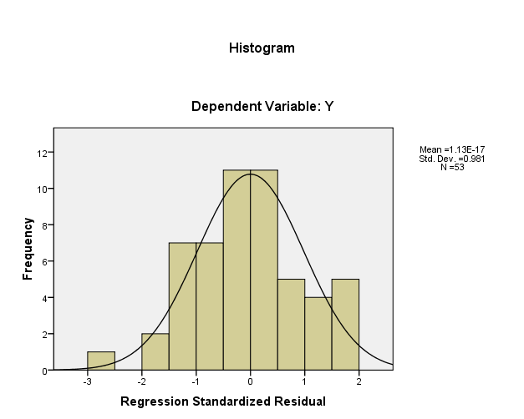

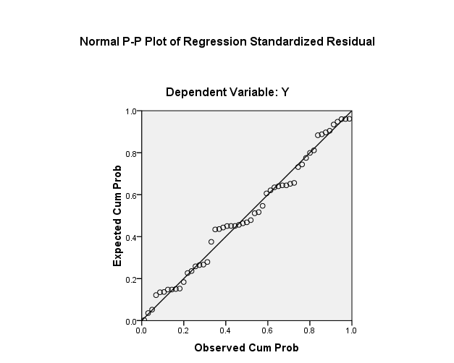
NPar Tests
One-Sample Kolmogorov-Smirnov Test
 |  | X1 | X2 | Y
N |  | 53 | 53 | 53
Normal Parametersª | Mean | 33.4906 | 30.7547 | 34.0000
Normal Parametersª | Std. Deviation | 3.40035 | 4.32749 | 4.59933
Most Extreme Differences | Absolute | .126 | .104 | .145
Most Extreme Differences | Positive | .055 | .104 | .133
Most Extreme Differences | Negative | -.126 | -.080 | -.145
Kolmogorov-Smirnov Z |  | .914 | .755 | 1.052
Asymp. Sig. (2-tailed) |  | .373 | .618 | .218
a. Test distribution is Normal.

